ADMINISTRATIVE REVIEW – MODIFICATIONS TO DEVELOPMENT STANDARDS

Section 1: That Mesa City Code Title 11 Section 11-1-5 is hereby amended as follows:
11-1-5: - CONSISTENCY WITH THE GENERAL PLAN
Each application for A Special Use Permits, Council Use Permits, site DEVELOPMENT pPlan review, site DEVELOPMENT pPlan mModification or request to modify the zoning classification of a parcel of land shall be reviewed and evaluated for consistency with the City of Mesa General Plan. With regard to requests to modify the zoning classification of specific parcels of land, where there is a conflict between this Ordinance and the General Plan, the General Plan shall prevail.
…
Section 2: That Mesa City Code Title 11 Section 11-2-3 is hereby amended as follows:
11-2-3: - RULES FOR MEASUREMENT
…
F. Measuring Lot Width and Depth.
1. Lot Width. Lot width is tThe horizontal distance between the side lot PROPERTY lines OF A LOT, measured at right angles to the lot depth ALONG THE REQUIRED FRONT SETBACK. Minimum lot width is measured perpendicular to the lot depth at both the front and rear setbacks, based on the applicable zoning district applied to the property.
2. Lot Depth. Lot depth is THE DISTANCE MEASURED FROM measured along an imaginary straight line drawn from the midpoint of THE MIDPOINT OF the front property line of the lot to the midpoint of the rear property line, or to the REAR most distant point on any other OF THE lot line where there is no rear lot line.
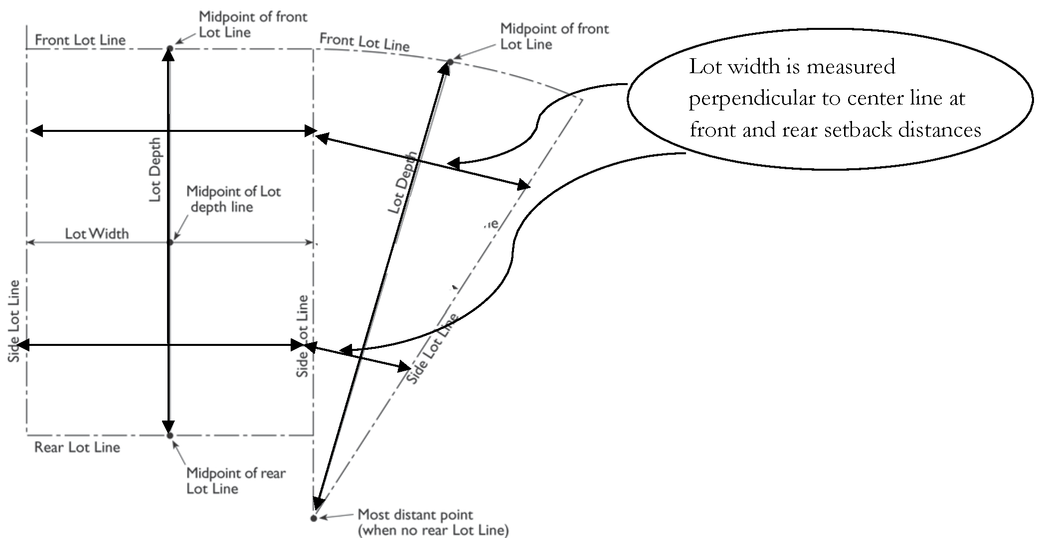
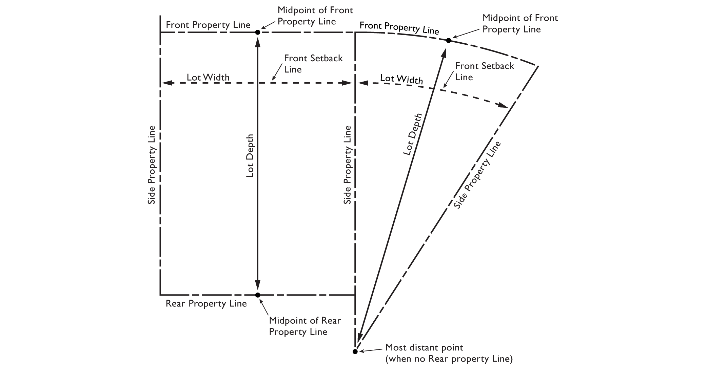
FIGURE 11-2-3.F: MEASURING LOT WIDTH AND DEPTH
…

  - Determining Floor Area.
    - Gross Floor Area. As defined in Chapter 87, includes the floor area of garages, carports, ventilation shafts, shafts, elevators, corridors, mechanical rooms, closets, storage and equipment storage rooms, open porches, balconies, courts, atriums, lobby areas basements, MEZZANINES, INTERIOR BALCONIES, AND ALL UPPER STORIES OR LEVELsand attics.
    - Floor Area (HABITABLE FLOOR AREA, Net Floor Area). As defined in Chapter 87, excludes the floor area of garages, carports, ventilation shafts, elevators, stairways, corridors, bathrooms, mechanical rooms, closets, storage and equipment storage rooms, open porches, balconies, courts, atriums, lobby areas, basements, and attics. INCLUDES SPACE IN A BUILDING FOR PURPOSES INCLUDING LIVING, WORKING, SLEEPING, SANITATION, EATING, COOKING, CONDITIONED STORAGE, RECREATION, OR ANY COMBINATION OF THE ABOVE. SPACE USED ONLY FOR UNCONDITIONED STORAGE OR PARKING IS NOT HABITABLE SPACE.
…
- Determining Setbacks for Yards. A setback line defining a required yard is parallel to and at the specified distance from the corresponding front, side, or rear property line. The following special regulations for determining yards applySHALL BE MEASURED PERPENDICULAR TO A PROPERTY LINE EXCEPT when a lot abuts a proposed street or alleyAS FOLLOWS:
- Yards LOTS OR PARCELS Abutting Planned Street Expansions. If a property LOT OR PARCEL abuts an existing or proposed street for which the existing right-of-way is narrower than the right-of-way ultimately required for the street as determined by the City Council through the latest adopted transportation and/or street plan, the required setback shall be established from the future right-of-way rather than the property line. In the event that the street is not listed under the latest adopted transportation plan, the street width shall be determined based on the street classification and right-of-way width requirements specified in Title 9, Chapter 6 of the Mesa City Code.

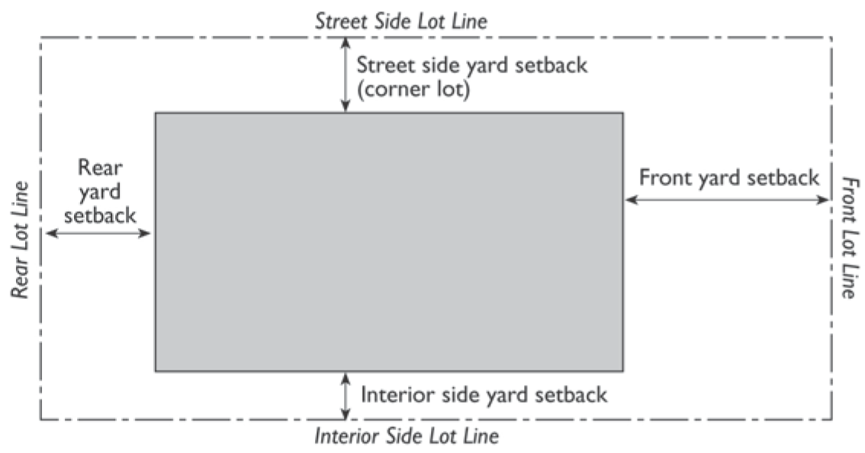

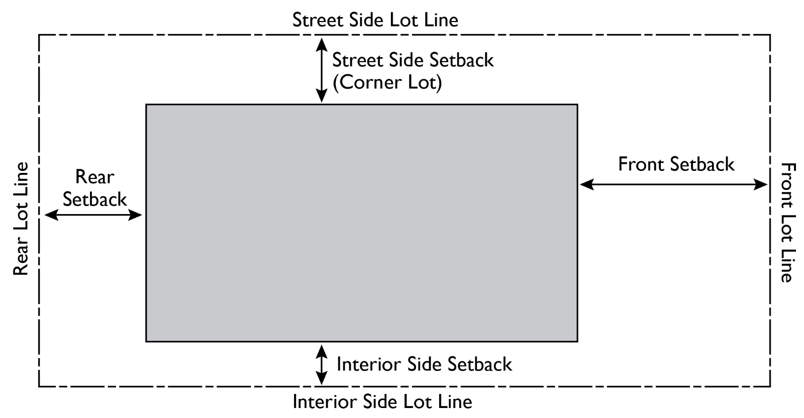
FIGURE 11-2-3.L: DETERMINING SETBACKS
- Yards on LOTS OR PARCELS ABUTTING AN Alleys.
- If a side lot PROPERTY line abuts an alley, the yard SETBACK shall be considered an interior side yard SETBACK rather than a corner side yard.
- In computing the minimum yard for any lot where such yard abuts NO PART OF an alley RIGHT-OF-WAY MAY BE, no part of the width of the alley may be considered as part of the required yard SETBACK except rear WHEN A LOT OR PARCEL ABUTS AN ALLEY, EXCEPT FOR REAR yards SETBACK in RS dDistricts, as specified by Section 11-5-3(D) IN CHAPTER 5 OF THE ZONING ORDINANCE.
…
Section 3: That Mesa City Code Title 11 Section 11-3-1 is hereby amended as follows:
11-3-1: - DISTRICTS ESTABLISHED
…

B. Overlay Zones. Overlay zones, one (1) or more of which may be combined with one (1) or more base districts, are established as follows:
Short Name/Map Symbol | Full Name
AF | Airfield
AS | Age-Specific
BIZ | Bonus Intensity Zone
PAD | Planned Area Development
HD | Historic District
HL | Historic Landmark
DE | Downtown Event
BO | BILLBOARD OVERLAY DISTRICT

C. Community Character Designators. Recognizing that not all areas of the City are the same, two community character designators have been established to enhance some multi-residence, commercial and mixed-use districts. These designators are combined with the base district abbreviations in order to establish area-specific development standards according to the intended development character.
1. Urban (-U). This designation is intended for areas with an urban character, where buildings are built close to the street and sidewalk to provide a close relationship between pedestrians and shops. Site and building design standards will reinforce this character and require treatments that provide an interesting, safe and comfortable pedestrian environment. This designation may apply to some areas where a few auto-oriented uses exist, but where creating, restoring, or maintaining a pedestrian character is called for in the General Plan, a Sub-Area Plan or other City policy.
2. Auto-Oriented (-A). This designation is intended for areas that provide for easy automobile access. Examples include Large Commercial Development buildings that may be located at the back or side of a site with parking in front. Standards are intended to mitigate the impact of the parking lots and buffer adjacent residential areas.
3. Associated Districts. The districts that may utilize the character designators are as follows:
Short Name/Map Symbol | Full Name | Associated Zoning Districts
U | Urban | RM - Residential Multiple Dwelling
U | Urban | NC - Neighborhood Commercial
U | Urban | LC - Limited Commercial
U | Urban | OC - Office Commercial
U | Urban | MX - Mixed Use
A | Auto | LC - Limited Commercial
A | Auto | GC - General Commercial
A | Auto | OC - Office Commercial

DC. References to Classes of Base Districts. Throughout the Ordinance, base zoning districts may be referred to as a group or in a singular manner through the use of the associated words listed as "Synonymous Terms" in the table below, based on the context of how the phrase is used.
Base Zoning District Groups | Associated Synonymous Terms
Residential Groups
RS, Residential Single-Dwelling;  RM, Residential Multiple-Dwelling;  RSL, Residential Small Lot Single-Dwelling;  DR, Downtown Residential | R-Zone;  R-District;  Residential Zone; OR  or Residential District
Commercial Groups
NC, Neighborhood Commercial;  LC, Limited Commercial;  GC, General Commercial;  OC, Office Commercial | C-Zone;  C-District;  Commercial Zone; OR  or Commercial District
Mixed Use Groups
MX, Mixed Use;  DB, Downtown Business;  DC, Downtown Core  PC, PLANNED COMMUNITY | Mixed-District;  Mixed-Zone
Industrial or Employment Groups
LI, Light Industrial;  GI, General Industrial;  HI, Heavy Industrial;  and PEP, Planned Employment Park;  EO, Employment Opportunity | I-Zone;  I-District;  Industrial Zone;  Industrial District;  Employment District; OR  or Employment Zone
Downtown Groups
DR, Downtown Residential;  DB, Downtown Business;  DC, Downtown Core | Downtown District;  Downtown Zone
Form-Based Code or Transect Groups
T3N, T4N, T4NF, T4MS, T5N, T5MSF, T5MS, T6MS | Transects
INFILL DISTRICT GROUPS
ID, INFILL DEVELOPMENT | ID-ZONE;  ID DISTRICT
PUBLIC AND SEMI-PUBLIC GROUPS
PS, PUBLIC AND SEMI-PUBLIC,  LR, LEISURE AND RECREATION | PS DISTRICT;  LR DISTRICT
…

Section 4: That Mesa City Code Title 11 Section 11-4-5 is hereby amended as follows:
11-4-5: - AGRICULTURE-BASED ENTERTAINMENT
…
A. Site DEVELOPMENT Plan. A finding that an acceptable site DEVELOPMENT pPlan has been submitted for review and consideration. Such site DEVELOPMENT pPlan shall adequately addresses issues relating to vehicle access, traffic circulation, and pedestrian safety.
…
Section 5: That Mesa City Code Title 11 Section 11-10-3 is hereby amended as follows:
11-10-3: - DEVELOPMENT STANDARDS
Table 11-10-3 and the subsection that follows it prescribe the development standards for the PS District.
Table 11-10-3: Development Standards - PS Public and Semi-Public District
Site Standards
Minimum Site Area (sq. ft.) | None
Building Form and Location
Maximum Height (ft.) | 30 ft. within 60 ft. of RS, RSL, and DR-1  60 ft. all others
Minimum Front and Street-Facing Side YardSETBACK | Varies by classification of adjacent street:  6-lane arterial: 30 ft.  4-lane arterial: 20 ft.  Major or Midsection Collector: 25 ft.  Industrial/Commercial Collector: 20 ft.  Local Street: 20 ft.  Freeways: 30 ft. for buildings; 15 ft. for parking AREAS AND structures  Next to MX, OR DC, or any district with a U designator: Same as adjacent district
Minimum Interior Side and Rear YardSETBACK: Adjacent to RS District | Sites smaller than 5 acres: 20 ft.  Sites 5 acres or larger: 25 ft.
Minimum Interior Side and Rear YardSETBACK: Adjacent to RM District | Single-story building: 20 ft.  Two or more stories: 15 ft. per story
Minimum Interior Side and Rear YardSETBACK: Adjacent to Non-residential District | Single-story building: 15 ft.  Two or more stories: 15 ft. per story
Minimum Separation between Buildings on Same Lot (ft.) | One-story building: 25 ft.  Two-story building: 30 ft.  Three or more story building: 35 ft.
Supplemental Standards
Fences and Walls | Section 11-30-4, Fences and Freestanding Walls
Landscaping | Chapter 33, Landscaping
Lighting and Illumination | Section 11-30-5, Lighting and Illumination
Lots Splits and Subdivisions | Section 11-30-6; and Title 9, Chapter 6, Subdivision Regulations
Off-Street Parking and Loading | Chapter 32, On-Site Parking, Loading, and Circulation
Pedestrian Connections | Section 11-30-8, Pedestrian Connections
Projections above Height Limits | Section 11-30-3, Exceptions to Height Limits
Setbacks at Intersections | Section 11-30-10, Setbacks at Intersections
Screening | Section 11-30-9, Screening
Signs | Article 5, Signs
Solar Panels | Section 11-30-15, Solar Panels and Other Energy Production Facilities
Swimming Pools | Section 11-30-11, Swimming Pools
Trash Storage and Screening | Section 11-30-12, Trash and Refuse Collection Areas
Visibility at Intersections | Section 11-30-14, Visibility at Intersections

- Buffer Yards. A SIX (6) FOOT TALL screening wall 6 feet in height is required wherever a lot located in the PS District abuts an RS, RSL, or DR dDistrict at the time of development. In addition, if a lot in the PS District abuts a lot in an RS, RSL, or DR-1 dDistrict at the time of development, a landscape buffer of at least 15 feet wide shall be provided on the PS-zoned lot.
…
Section 6: That Mesa City Code Title 11 Section 11-11-2 is hereby amended as follows:
11-11-2: - LAND USE AND DEVELOPMENT REGULATIONS
…
3. Development Unit Land Use Plan. With the approval of each development unit there shall be a Development Unit Plan that shall identify:
a. The general location for the land use group and any sub-land use group (and may identify general locations for specific uses),.
b. The approximate amount of acreage for such group (or specific use),.
c. The intensity of development proposed at each location.
4. Site DEVELOPMENT Plan. With the approval of each Site DEVELOPMENT Plan the permitted uses shall be specified on the Site DEVELOPMENT Plan by reference to sub-land use group(s) or specific uses. Permitted uses at a specific site shall be limited to those specified on the approved Site DEVELOPMENT Plan; all other uses are prohibited.
…
Section 7: That Mesa City Code Title 11 Section 11-11-3 is hereby amended as follows:
11-11-3: - APPLICATION REQUIREMENTS
…
D. Conditions. The City Council may place conditions on its approval of a PC District, Community Plan, and/or modifications to either a PC District or a Community Plan. Such conditions of approval may include, but are not limited to: conditions to ensure implementation of the Community Plan in accordance with the Mesa General Plan, and other applicable plans and policies adopted by the City; conditions to achieve the purposes and intents described in Section 11-11-1; and, conditions requiring additional or different approval processes for development units, design guidelines, siteDEVELOPMENT plans, and/or areas within the PC District.
…
Section 8: That Mesa City Code Title 11 Section 11-11-4 is hereby amended as follows:
11-11-4: - COMMUNITY PLAN REQUIRED
…
10. Requirements and Administration for Future Site DEVELOPMENT Plans. Consistent with, and in addition to the requirements of this Chapter, the Community Plan shall set forth additional elements required of Site DEVELOPMENT Plan Review, additional submittal and process requirements for a site DEVELOPMENT pPlan, Site DEVELOPMENT Plan Modification, and additional criteria for review or modification of site DEVELOPMENT pPlans. Such additional requirements shall include, but are not limited to, specifying how Site DEVELOPMENT Plan Review requirements will be administered within a development unit, and set forth the review and approval process for Site DEVELOPMENT Plan Review. Such additional elements and criteria shall include, but are not limited to, criteria and requirements to ensure that site DEVELOPMENT pPlans will facilitate development compatible with adjacent properties and surrounding neighborhoods, will facilitate the implementation of the Community Plan, will facilitate appropriate transitions between differing developments, and will not overburden the transportation system, utility infrastructure or community facilities.
…
Section 9: That Mesa City Code Title 11 Section 11-11-5 is hereby amended as follows:
11-11-5: - REVIEW AND CONSIDERATION OF DEVELOPMENT UNIT PLANS
…
C. Development Unit Design Guidelines. Development Unit Design Guidelines shall be submitted that are consistent with, and provide further detail to, the Community Plan Design Guidelines. The Development Unit Guidelines shall include design themes, additional standards and concepts unique to the development unit, and shall be of sufficient detail to ensure cohesive, integrated, high-quality design. All siteDEVELOPMENT plans and development shall conform to, and be consistent with, the approved Development Unit Design Guidelines.
D. Development Unit Land Use Plan. A Development Unit Land Use Plan, as described in Section 11-11-2(C)(3), shall be of sufficient detail to ensure the compatibility of future development in the unit and compatibility with properties surrounding the unit, to ensure appropriate transitions between differing developments, to ensure that development will not overburden the transportation system, utility infrastructure or community facilities, and to facilitate the implementation of the Community Plan. All siteDEVELOPMENT plans and development shall conform to, and be consistent with, the approved Development Unit Land Use Plan.
…
Section 10: That Mesa City Code Title 11 Section 11-11-6 is hereby amended as follows:
11-11-6: - SITE DEVELOPMENT PLAN REVIEW

A. Pre-Submittal Conference. A Pre-Submittal Conference with the City Planning Director and Engineer, or their designee, is required prior to submittal of a site DEVELOPMENT plan application.
B. Site DEVELOPMENT Plan Approval Required. All non-single residence development within a PC District shall require an approved site DEVELOPMENT pPlan. All single residence developments shall meet this requirement through the subdivision process as required by Chapter 6, of Title 9 of the Mesa City Code. For all development requiring an approved site DEVELOPMENT pPlan, no building permit shall be issued for such sites until there is an approved site DEVELOPMENT pPlan.
C. Site DEVELOPMENT Plan Review. All sites shall be reviewed, and be subject to approval, by the Planning Director and his/her designees, unless otherwise designated by the adopted Community Plan.
D. Review and Conditions. Site DEVELOPMENT pPlans shall be reviewed for consistency with the requirements of this Chapter, the Community Plan and Development Unit Plans. Unless otherwise specified in the Community Plan, conditions may be imposed on the approval of any site DEVELOPMENT pPlan as may be deemed necessary to ensure that the site is designed in a way to facilitate compatibility with adjacent property and to ensure that the development will be in accordance with the Community Plan, the General Development Standards, Community Plan Design Guidelines, Development Unit Design Guidelines, and the Land Use Budget. The Community Plan may establish additional criteria for such conditions. Consistent with this Chapter and any additional criteria established in the Community Plan such conditions may include:
1. Revised building setbacks;
2. Revised landscaping;
3. Revised on-site parking and loading spaces;
4. Height and area limitations on structures;
5. Limited Vehicular access;
6. Placement and/or installation of walls, fences, and screening devices;
7. Installation of noise attenuating construction; and
8. Off-site improvements in public rights-of-way adjacent to the subject property.
E. Required Information. All applications for Site DEVELOPMENT Plan Review for development within an approved PC District shall include drawings (drawn to scale) and other supporting materials and documents, as determined by the Community Plan. Additional materials and plans may be requested, as needed, by the Planning Director to determine the full compatibility of the project to neighboring development.
F. Land Use Budget Update. The Master Developer shall review all siteDEVELOPMENT plans prior to submittal to ensure compliance with the land use budget. All siteDEVELOPMENT plans shall be submitted with a chart, approved by the Master Developer, updating the land use budgets for the Community Plan and the applicable Development Unit Plan.
G. Permitted Uses. The permitted uses shall be limited to those identified on the site DEVELOPMENT pPlan as described in Section 11-11-2(C)(4).
H. Appeal of a Site DEVELOPMENT Plan Review Decision Made by a City Board or the Planning Director. The applicant, any owner of property within 750 feet of the boundaries of the Site DEVELOPMENT Plan Review case or the City Manager (or his designee) may appeal a Site DEVELOPMENT Plan Review decision. The appeal shall be made in writing, specifying the grounds for the appeal, within 15 business days of the decision. An appeal from a decision by a City board shall be forwarded to the City Council for review and consideration. An appeal from a decision by the Planning Director shall be forwarded to the Planning and Zoning Board (unless specified otherwise in the Community Plan for review and consideration. It shall be the responsibility of the applicant to complete all citizen participation requirements. The appellate body shall rehear the request, and shall have the ability to affirm, reverse or modify the previous decision.
…
Section 11: That Mesa City Code Title 11 Section 11-11-7 is hereby amended as follows:
11-11-7: - EXPIRATION AND RENEWAL OF SITEDEVELOPMENT PLAN REVIEWS
A. Expiration. The approval of a siteDEVELOPMENT plan shall expire TWO (2) years following the date of the approval, unless a building permit has been issued and construction diligently pursued.
B. Extension. SiteDEVELOPMENT plan approval may be extended once for a period of not more than an additional two (2) years by the Planning Director. Application for an extension shall be made in writing not less than 30 days after and not more than 60 days before the expiration of the original approval. The Planning Director may extend a siteDEVELOPMENT plan approval if the siteDEVELOPMENT plan remains consistent with the purpose and intent of this Chapter, the Community Plan, and the applicable Development Unit Plan.
C. New Application. If the approval of a siteDEVELOPMENT plan expires and an extension to the approval is not, or cannot, be granted, a new application for Site DEVELOPMENT Plan Review shall be filed.
…
Section 12: That Mesa City Code Title 11 Section 11-11-10 is hereby amended as follows:
11-11-10: - SUPPLEMENTARY PROVISIONS
…
A. For the PC District, Community Plan, Development Unit Plan, Site DEVELOPMENT Plan Review, and amendment thereto, notice and citizen participation shall be in accordance with Article 7, Administration this Ordinance, except an adopted Community Plan may modify these notice and citizen participation requirements for approvals and amendments that the Community Plan establishes are to be subject to approval by the Planning Director or designee.
…
Section 13: That Mesa City Code Title 11 Section 11-12-5 is hereby amended as follows:
11-12-5: - INFILL INCENTIVE PLAN (IIP)
…
D. Development Regulations. The IIP shall list permitted General Development Standards and land use options, which may be assigned to specific parcels. Multiple development and land use options may be assigned and described as available alternatives.
1. ID-1 applications shall state the zoning district or districts, as listed in Section 11-3-1(A) Base Zones, being used to establish the uses permitted on the property. If more than one district is utilized, then the boundaries of each district shall be delineated on the IIP Map. The development standards associated with the designated district(s) shall govern development on the site unless deviations are requested as part of the application and approved with the adoption of the ID. If applicable, a character designation, as listed in Section 11-3-1(C), Community Character Designators, may be used to define the default development standards. The application must also include any requests for modification of development standards contained in, or authorized by Title 9 of the Mesa City Code.
2. ID-2 applications shall submit either of the following:
a. A list of base district(s) and/or character designator(s), as described in 1, above; or
b. A specific land use plan including allowed land uses and activities that may or may not necessarily correspond to specific base zoning districts. If this option is chosen, the adopted IIP shall govern allowed land use activities for the project site.
…
Section 13: That Mesa City Code Title 11 Section 11-14-3 is hereby amended as follows:
11-14-3: - APPLICATION REQUIREMENTS
D. Conditions. In approving an EO District, the City Council may place conditions for its approval, and the approval of the associated EO Development Plan. Such conditions of approval may include, but are not limited to:
1. Conditions to ensure implementation of the EO Development Plan in accordance with the Mesa General Plan, and other applicable plans and policies adopted by the City;
2. Conditions to achieve the purpose of this Chapter;
3. Conditions requiring additional or different approval processes for siteDEVELOPMENT plans within the EO District; and
4. Conditions requiring execution of a development agreement, intergovernmental agreement, intergovernmental development agreement or similar agreement, or an amendment to an existing agreement.
…
Section 14: That Mesa City Code Title 11 Section 11-14-4 is hereby amended as follows:
11-14-4: - COMMUNITY PLAN REQUIRED
…

D. Conditions. In approving an EO District, the City Council may place conditions for its approval, and the approval of the associated EO Development Plan. Such conditions of approval may include, but are not limited to:

1. Conditions to ensure implementation of the EO Development Plan in accordance with the Mesa General Plan, and other applicable plans and policies adopted by the City;

2. Conditions to achieve the purpose of this Chapter;

3. Conditions requiring additional or different approval processes for siteDEVELOPMENT plans within the EO District; and

4. Conditions requiring execution of a development agreement, intergovernmental agreement, intergovernmental development agreement or similar agreement, or an amendment to an existing agreement.
…
Section 15: That Mesa City Code Title 11 Section 11-14-6 is hereby amended as follows:
11-14-6: - SITEDEVELOPMENT PLAN REVIEW
A. Pre-Submittal Conference.
1. A Pre-Submittal Conference with the Planning Director and City Engineer, or their designee(s), is required prior to submittal of a siteDEVELOPMENT plan application; except
2. A Pre-Submittal Conference may be waived for Qualified Political Subdivisions if expressly set forth in the approved EO Development Plan.
B. SiteDEVELOPMENT Plan Approval Required.
1. All development within an EO District shall require SiteDEVELOPMENT Plan Review approval from the City of Mesa; except
2. The requirement for SiteDEVELOPMENT Plan Review may be waived for Qualified Political Subdivisions if expressly set forth in the approved EO Development Plan and the intergovernmental agreement, intergovernmental development agreement, or similar agreement for the EO District.
C. Required Information. Unless exempt from SiteDEVELOPMENT Plan Review, development applications within an approved EO District shall include:
1. Identification of the proposed range of land use classifications, or, when used, the LUGs specified for the development site by the EO Development Plan;
2. Drawings (drawn to scale), including a siteDEVELOPMENT plan, landscape plan, and building elevations;
3. Other supporting materials and documents, as determined by the EO Development Plan; and
4. Additional materials and plans may be requested by the Planning Director to determine full compliance with the EO Development Plan, and compatibility of the project to neighboring development.
D. Land Use Boundaries Set by SiteDEVELOPMENT Plan Review.
1. When distinct, multiple LUGs are used in an EO Development Plan, the siteDEVELOPMENT plan approved for a specific location or land parcel will set boundaries and shall designate which LUG applies.
2. All future use and development of that site shall conform to the requirements of that specified LUG unless a different LUG is otherwise approved by the Planning Director as a part of a subsequent SiteDEVELOPMENT Plan Review application.
E. SiteDEVELOPMENT Plan Review Process.
1. Unless exempt under an approved EO Development Plan, siteDEVELOPMENT plans shall be reviewed and approved by the Planning Director or designee(s), through the administrative process unless a site within the EO Development Plan area is otherwise designated for review by public hearing by the approved EO Development Plan.
2. Exemptions for Qualified Political Subdivisions.
a. A Qualified Political Subdivision may identify in the EO Development Plan and the intergovernmental agreement, intergovernmental development agreement, or similar agreement for the EO District, the categories of land uses, development activities, projects, and sites that are exempt from the City’s siteDEVELOPMENT pPlan rReview and approval process and which siteDEVELOPMENT plans are subject to the Qualified Political Subdivision’s review and approval processes (including siteDEVELOPMENT pPlan mModification and renewal processes), and siteDEVELOPMENT plan expiration timeframes.
b. Any exemption must be expressly set forth in the EO Development Plan and is subject to further regulation in, and compliance with, an intergovernmental agreement, intergovernmental development agreement, or similar agreement.
F. Review and Conditions.
1. SiteDEVELOPMENT plans shall be reviewed for consistency with the requirements of the EO District and the approved EO Development Plan.
2. Conditions may be imposed on the approval of any siteDEVELOPMENT plan as may be deemed necessary by the Planning Director to ensure that the site is designed in a way to facilitate compatibility with adjacent property, and to ensure that the development will be built in accordance with the approved EO Development Plan.
3. The EO Development Plan may establish additional criteria for such conditions. Consistent with this Chapter and any additional criteria established in the EO Development Plan, such conditions may include:
a. Revised building setbacks;
b. Revised landscaping;
c. Revised on-site parking and loading spaces;
d. Height and area limitations on structures;
e. Limited vehicular access;
f. Placement and/or installation of walls, fences and screening devices;
g. Installation of noise attenuating devices or construction;
h. Off-site improvements in public rights-of-way adjacent to the subject property; and
i. Placement of all detached signs.
FG. Expiration and Renewal of SiteDEVELOPMENT Plan Approvals.
1. Expiration. The approval of a siteDEVELOPMENT plan located within an approved EO District shall expire twoFIVE (25) years following the date of the approval, unless a building permit has been issued and construction diligently pursued.
2. Extension.
a. SiteDEVELOPMENT plan approval may be extended once for a period of not more than ONE (1) an additional two (2) years by the Planning Director.
b. Application for an extension shall be made in writing not more than 60 days before and not more than 30 days after the expiration of the original approval.
c. The Planning Director may extend a siteDEVELOPMENT plan approval if the siteDEVELOPMENT plan and any minor revisions approved since the initial adoption of the SiteDEVELOPMENT Plan Review remain consistent with the purpose and intent of this Chapter, and the applicable EO Development Plan.
3. New Application. If the approval of a siteDEVELOPMENT plan expires and an extension to the approval is not, or cannot, be granted, a new application for SiteDEVELOPMENT Plan Review shall be required.
…
Section 16: That Mesa City Code Title 11 Section 11-14-8 is hereby amended as follows:
11-14-8: - ADMINISTRATIVE NOTICING, PROCESS, AND APPEALS

A. Administrative Actions. The following requests shall be reviewed on an administrative basis:

1. SiteDEVELOPMENT Plan Reviews unless a site within the EO Development Plan area is otherwise designated for review by public hearing by the approved EO Development Plan;

2. SiteDEVELOPMENT Plan Modifications;

3. Minor Adjustments to General Development Standards; and

4. Minor Amendments to the EO Development Plan.

…

D. Appeals to the Planning and Zoning Board.

1. A Planning Director action or decision on a siteDEVELOPMENT plan, siteDEVELOPMENT pPlan mModification, minor EO Development Plan amendment, or minor General Development Standards adjustment may be appealed by the applicant, or by an owner of property located within 750 feet of the property that is the subject of the Planning Director’s decision.

2. A written notice of appeal shall set forth the information required in Section 11-77-4(B) and shall be filed within 15 calendar days from the date of the Planning Director's decision and shall be heard by the Planning and Zoning Board.
…
Section 17: That Mesa City Code Title 11 Section 11-21-5 is hereby amended as follows:
11-21-5: - REVIEW OF PLANS
…
C. Building Permits and Regulations.
1. An approved development may be built in phases upon approval of a phasing plan. Any phasing plan must provide, at a minimum, that the construction and provision of all necessary elements associated with that phase, including parking, drainage, common open spaces, and public and recreational facilities, which are shown on the approved siteDEVELOPMENT plan, are constructed prior to or contemporaneously with the construction of buildings for that phase. If the City Manager or designee determines that the rate of building construction does not conform to the approved phasing plan, he shall notify the developer that no new building permits shall be issued until the developer obtains approval of a supplemental Phasing Plan designed to restore compliance with the previously approved Phasing Plan. In the alternative, the developer may submit a proposed revision to the Phasing Plan for Planning Director review and possible approval. Failure to comply with the terms of this Section in a timely manner following notification shall result in all building construction being halted and all existing building permits shall be suspended until a supplemental or revised Phasing Plan is approved by the Planning Director.
…
Section 18: That Mesa City Code Title 11 Section 11-22-1 is hereby amended as follows:
11-22-1: - PLANNED AREA DEVELOPMENT OVERLAY DISTRICT
The purpose of the Planned Area Development Overlay (PAD) District is to permit flexibility in the application of zoning standards and requirements where it can be demonstrated that the proposed development provides equivalent or superior standards in a creative way to meet the intent of the underlaying zoning district and general plan. This overlay district allows for innovative design and flexibility in projects of sufficient size that are planned for development as a cohesive unit and may also be used to organize a development in phases by using conceptual development plans and deferring specific siteDEVELOPMENT plan approval to a future date. The intent of this district is to provide for creative, high-quality development incorporating:
…
Section 19: That Mesa City Code Title 11 Section 11-30-3 is hereby amended as follows:
11-30-3: - EXCEPTIONS TO HEIGHT LIMITS
…
C. Additional Exceptions. The Design Review Board may approve additional exceptions to the height limits specified in this Ordinance only upon a finding by the Board that:
1. The proposed development does not exceed the maximum number of stories or residential densities permitted in the zoning district in which it is located; and.
2. At least one of the following items is present:
a. Increased setbacks, enhanced landscaping, or other screening measures effectively mitigate the impact of the building height; or
b. The exception is necessary to accommodate the proposed uses or activities within the building or structure; or
c. The architectural style of the building or structure places the exception at a central point or in a limited area such as a dome, sphere, or other geometric solid.
…
Section 20: That Mesa City Code Title 11 Section is hereby amended as follows:
11-30-4: - FENCES AND FREESTANDING WALLS
…
  - AG, RS, RSL, RM, and DR Districts.
…
    - Prohibited Materials. The use of barbed wire, razor wire, embedded glass shards, ultra barrier, electrified and other hazardous fencing is prohibited, except for the use of barbed wire fencing used for livestock enclosures.
      - ACCEPTABLE MATERIALS. WALLS AND FENCES SHALL BE CONSTRUCTED OF HIGH-QUALITY, DURABLE MATERIALS SUCH AS STUCCO FINISH, MASONRY OR CONCRETE BLOCK, BRICK, DECORATIVE CAP BLOCK, WROUGHT IRON, OR OTHER SIMILAR HIGH-QUALITY MATERIAL.
      - PROHIBITED MATERIALS. THE USE OF CHAIN-LINK, BARBED WIRE, RAZOR WIRE, EMBEDDED GLASS SHARDS, ULTRA BARRIER, ELECTRIFIED AND OTHER HAZARDOUS FENCING IS PROHIBITED, EXCEPT FOR THE USE OF BARBED WIRE FENCING USED FOR LIVESTOCK ENCLOSURES.
…
  - Fence AND WALL Articulation. The maximum length of continuous, unbroken, and uninterrupted fence or wall plane adjacent to right-of-way or private streets functioning as public roads shall be forty (40) 150 feet. Articulation shall be provided through the use of columns, POSTS, VARIED HEIGHT, PROTRUSIONS AND RECESSES IN THE HORIZONTAL PLANElandscaped pockets and/or a change to different materials.
    - POST AND COLUMNS SHALL PROTRUDE A MINIMUM OF SIX (6) INCHES FROM THE ADJACENT PLANE.
    - PROTRUSIONS AND RECESSES IN THE HORIZONTAL PLANE, AND VARIATIONS IN HEIGHT SHALL BE A MINIMUM 18 INCHES.
…

Section 21: That Mesa City Code Title 11 Section 11-30-5 is hereby amended as follows:

11-30-5: - LIGHTING AND ILLUMINATION
The objective of this section is to promote well designed lighting that can enhance the design of a building or site by highlighting interesting architectural details, calling attention to interesting textures and colors, and focusing attention to primary site features. Such lighting should be controlled to minimize adverse impacts to abutting residential uses.
A. Applicability: The requirements of this Section shall apply to all projects except Single Residence sDwellings and duplex residence dwellings (2 dwellings on one 1 lot or parcel)MIDDLE HOUSING.
B. Parking Lot Illumination.
1. LOCATION. Light standards POLES shall be located only within the parking area or, where permitted, the outdoor storage area, and shall not encroach into required perimeter landscape areas.
- LIGHT POLE HEIGHTS.
  - MAXIMUM LIGHT POLE HEIGHT SHALL BE 15 FEET WHEN WITHIN 50 FEET OF THE PERIMETER OF THE DEVELOPMENT AND ADJACENT TO A RESIDENTIAL USE OR ZONING DISTRICT.
  - WHEN ADJACENT TO ANY OTHER USE, THE MAXIMUM HEIGHT SHALL BE 20 FEET WITHIN 50 FEET OF THE PERIMETER.
  - THE MAXIMUM HEIGHT SHALL BE 25 FEET EVERYWHERE ELSE ON THE SITE.
23. LIGHT SHIELDS. House side shields shall be provided on all light standards adjacent to residential development.
34. BUILDING MOUNTED LIGHTS. Building mounted lights shall maintain the same heights as specified in BC, below.
45. LIGHTING AND ELECTRIC CODE. For additional standards refer to the Mesa Lighting and Electrical Code; Title 4, Chapter 4 of the Mesa City Code.
C. Maximum Height of Lighting Fixtures. Design Objective: Provide sufficient height to safely light areas without impacting adjacent residential development or contributing to light pollution.
1. Lighting fixtures, including freestanding light poles as well as building-mounted lights, shall not exceed the maximum heights specified in Table 11-30-5 below.
Table 11-30-5: Maximum Height of Lighting Fixtures
District | Maximum Height (ft.) - Detached | Maximum Height (ft.) - Attached
Residential Districts | 15 | Not to exceed the peak elevation of the immediately adjacent sloped roof, parapet, or building elevation to which the fixture is attached
DC; and DB Districts all non-residential districts with U designators | 1620
All other non-residential dDistricts | Within 50 feet of any street frontage: 20 ft.  Within 50 feet of a rResidential dDistrict: 15 ft.  Any other location: 25 ft.

2. Exceptions to the maximum height of lighting fixtures may be approved by the Zoning Administrator, after a review of a photometric study for compliance with Section 11-30-5(A). Such exceptions may include requirements for use light control devices, such as fully shielded or full cut-off fixtures, to reduce glare and light-spillage onto abutting properties.

D. Exposed Exterior Building Illumination. Design Objective: Contribute to the safety of the nighttime environments and accentuate architectural elements. EXPOSED NEON, ARGON, LED OR KRYPTON TUBING; EXPOSED INCANDESCENT LIGHTING; OR OTHER EXPOSED ARTIFICIAL LIGHTING USED TO OUTLINE OR ACCENT A STRUCTURE OR PORTION THEREOF IS PERMITTED SUBJECT TO THE FOLLOWING:

1. Findings for Approval. The use of exposed neon, argon, LED or krypton tubing, exposed incandescent lighting, or other exposed artificial lighting to outline any structure or portion thereof may be authorized after review and approval by the Design Review Board. The Board shall approve exposed building illumination only upon a finding that such illumination:
a. Constitutes a design component of the overall building architecture; and
b. Is integrated into the primary physical elements of the building or development, and is harmonious with the architectural style of the structure(s); and
c. Serves only for the purpose of embellishing the nighttime architecture of the building, and does not portray an advertising message; and
d. Is compatible with the land use and architecture of adjacent developments.
2. Substantial Conformance Required. Any approval by the Design Review Board for exposed building illumination requires finding that the structure or building complex on which the lighting is to be used shall be in substantial compliance with all current Mesa City Code requirements and regulations.

1. PLACEMENT.
A. EXPOSED LIGHTING SHALL BE MOUNTED WITHIN 12 INCHES OF A PERMANENT ARCHITECTURAL ELEMENT (E.G., PARAPET OR CORNICE LINE, CANOPY/AWNING EDGE, PILASTER/COLUMN, ENTRY SURROUND) AND SHALL NOT BE FREESTANDING ON BLANK WALL AREAS.
B. EXPOSED LIGHTING SHALL NOT BE PLACED ABOVE THE ROOF OR PARAPET, OR ON ROOFTOP EQUIPMENT OR ON TOP OF FENCES.
2. QUANTITY. A MAXIMUM OF TWO (2) HORIZONTAL RUNS (E.G. ALONG PARAPET OR CANOPY EDGES) AND ONE (1) VERTICAL RUN (E.G. ALONG CORNERS OR ENTRY SURROUNDS) IS PERMITTED ON EACH FAÇADE.
3. COLOR. ONE (1) STATIC COLOR OR HUE IS PERMITTED PER BUILDING.
4. ADVERTING/SIGNAGE PROHIBITED. TUBING SHALL NOT FORM LETTERS, NUMBERS, SYMBOLS, LOGOS, PRODUCT SHAPES, OR TRADEMARK COLOR PATTERNS, AND SHALL NOT BE ATTACHED TO OR INTEGRATED WITH ANY SIGN FACE.
5. MOTION AND EFFECTS PROHIBITED. FLASHING, BLINKING, PULSING, CHASING, AND STROBING EFFECTS ARE PROHIBITED.
6. Full Functionality Required for Use. If any component OR SEGMENT of the lighting system becomesIS nonfunctional, ALL EXPOSED LIGHTING ON THE BUILDING SHALL REMAIN OFF until the entire lighting system is FULLY repaired.
…
Section 22: That Mesa City Code Title 11 Section 11-30-7 is hereby amended as follows:

11-30-7: - OUTDOOR STORAGE
…
Table 11-30-7: Open OUTDOOR Storage Regulations by District and Location
Base Districts | Permissibility of Open OUTDOOR Storage
Neighborhood Commercial (NC), Limited Commercial (LC), Mixed Use (MX), and Downtown Business (DB) | All storage shall be within an enclosed building except as specified for accessory outdoor display.
Planned Employment Park (PEP) | All storage shall be within an enclosed building.
General Commercial (GC), and Light Industrial (LI) | Not permitted in front or SStreet-facing SSide YardsSETBACKS. Permitted in interior side and RRear YardsSETBACKS, WITHIN or outside of required yards, subject to the standards of this Section THE REAR ONE-HALF OF THE LOT, SUBJECT TO THE STANDARDS OF THIS SECTION.
GENERAL INDUSTRIAL (GI) | NOT PERMITTED IN FRONT OR STREET-FACING SIDE SETBACKS OR IN FRONT OF THE PRIMARY BUILDING(S).
General Industrial (GI) and Heavy Industrial (HI) | Permitted anywhere on a lot or parcel, subject to the standards of this Section.
Agricultural (AG), Single Residence (RS), Small Lot Single Residence (RSL), Downtown Residence (DR), and Multiple Residence (RM) | Any individual tool or piece of equipment that is higher than four (4) feet and in which the added aggregate measurements of the length, width, and depth (length plus width plus depth) exceeds 15 lineal feet, based on the extreme perimeter measurements, shall be placed  or stored within an enclosed building. ^{(1, 2, 3)}
1. Equipment specifically designed and used for agriculture (as defined in Section 11-86-7 of this Title), Utility Trailers and Watercraft (as defined in Section 8-6-2 of the Mesa City Code), Recreational Vehicles (as defined in Chapter 87 of this Title), and other motorized vehicles eligible for licensing by the State of Arizona for travel on public thoroughfares are excluded from this requirement.
2. Recreational Vehicle parking requirements are provided in Section 11-34-5(B) of this Title.
3. Requirements for parking and storage of Watercraft and Utility Trailers are provided in Section 8-6-3 of the Mesa City Code.

C. Screening and Setbacks. OUTDOOR Storage areas visible from public AND PRIVATE SStreets shall be screened BY A WALL.
    - Screening Walls. Screening walls and fences shall be at least eight (8) feet in height. If located on a SStreet FFacing front or SSide SETBACKYard, the WALLFence shall be placed to meet required FRONT AND SStreet-side SSetbacks.
    - MATERIALS. SCREEN WALL MATERIALS SHALL BE OPAQUE AND DURABLE AND SHALL INCORPORATE ELEMENTS OF THE BUILDING DESIGN E.G. SHAPE, COLOR, TEXTURE, AND MATERIAL.
    - Landscaping. Landscaping is not required within screened storage areas. ALL OTHER REQUIRED LANDSCAPED AREAS SHALL CONFORM TO CHAPTER 33: LANDSCAPING.
    - Setback. A SSetback shall be provided for material stored outdoors at the ratio of 1:1 from all LLot LLines equal to total height of stored material above the required eight (8) foot screen wall.
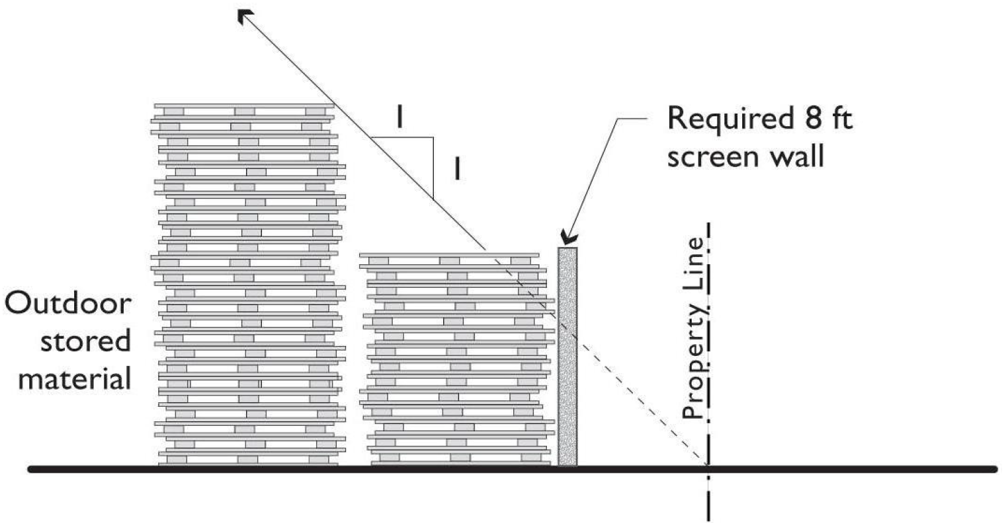
FIGURE 11-30-7.C(1)
…
Section 23: That Mesa City Code Title 11 Section 11-30-8 is hereby amended as follows:

11-30-8: - PEDESTRIAN CONNECTIONS
Design Objective: Encourage people to walk by providing safe, convenient, comfortable and efficient pedestrian connections.
Pedestrian walkways shall be provided in office, employment, commercial, mixed-use, and multiPLE family residential RESIDENCE developments. These walkways shall be designed to serve internal pedestrian circulation needs, and shall connect to public sidewalks and transit stops. Pedestrian access must be provided according to the following standards:
  - Off-Site Connections. Connection to Public Sidewalk. An on-site walkway shall connect the main entry of each building or each primary entry to a public Sidewalk on each Street frontage of the site, and to any transit stop adjacent to the site. On at least one frontage, such walkway shall be provided along the shortest practical distance between the main building entry and Sidewalk, generally no more than 125 percent of the straight-line distance. The distance may increase up to 50% of the total straight-line distance in the event the route is designed to take account of afternoon shade patterns from buildings or similar shading devices.
    - CONNECTION TO PUBLIC SIDEWALK. AN ON-SITE WALKWAY SHALL CONNECT THE MAIN ENTRY OF EACH BUILDING OR EACH PRIMARY ENTRY TO A PUBLIC SIDEWALK ON EACH STREET FRONTAGE OF THE SITE.
      - ON AT LEAST ONE (1) STREET FRONTAGE, SUCH WALKWAY SHALL BE PROVIDED ALONG THE SHORTEST PRACTICAL DISTANCE BETWEEN THE MAIN BUILDING ENTRY AND SIDEWALK, GENERALLY NO MORE THAN 125% OF THE STRAIGHT-LINE DISTANCE.
      - THE DISTANCE MAY INCREASE UP TO 50% OF THE TOTAL STRAIGHT-LINE DISTANCE IN THE EVENT THE ROUTE IS DESIGNED TO TAKE ACCOUNT OF AFTERNOON SHADE PATTERNS FROM BUILDINGS OR SIMILAR SHADING DEVICES.
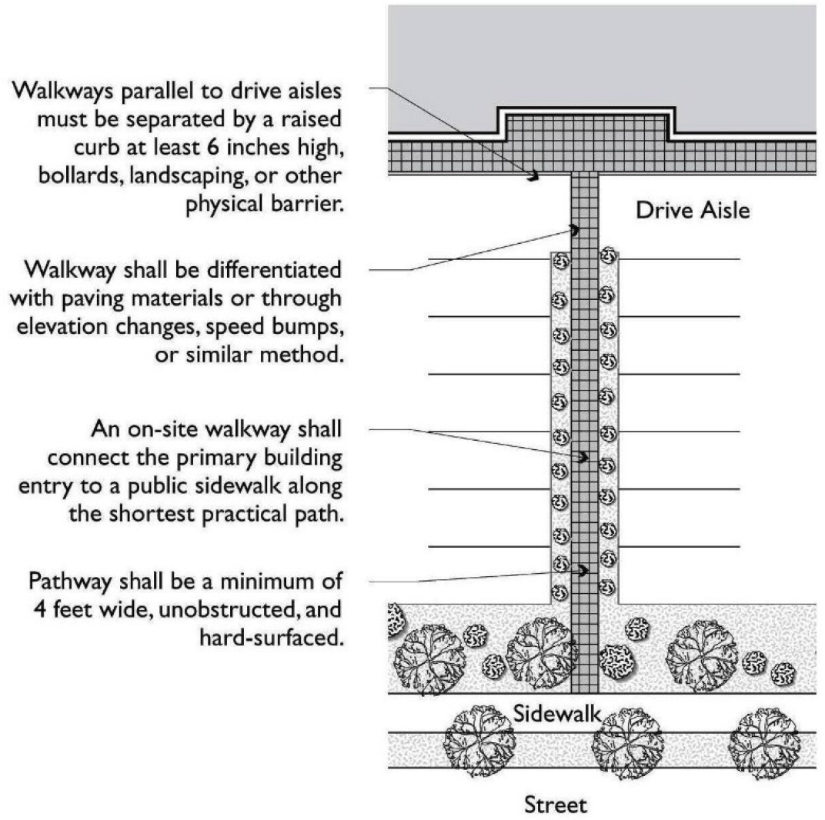

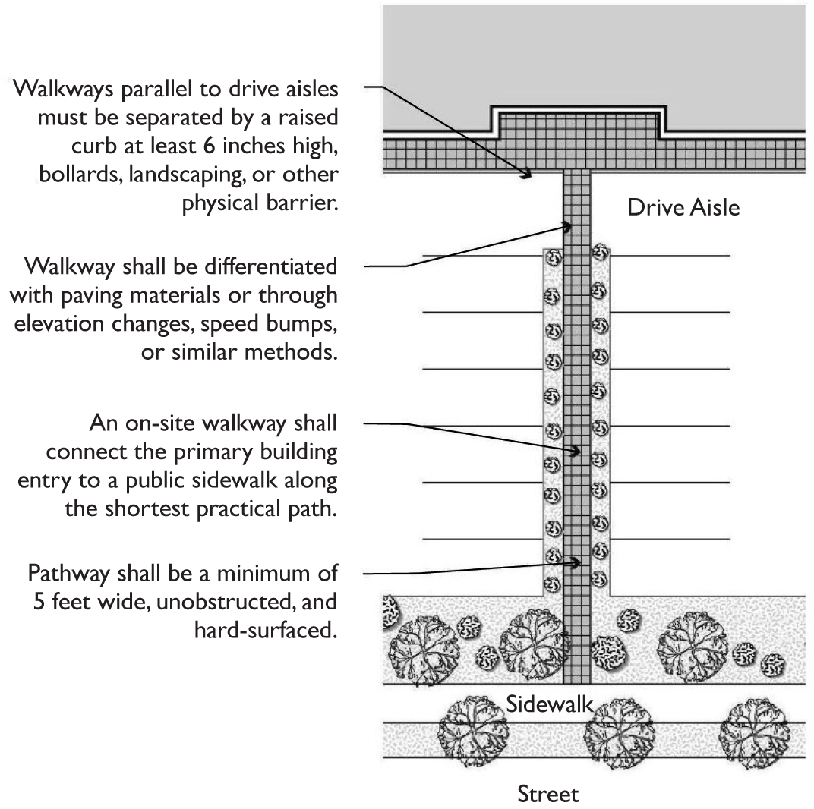
FIGURE 11-30-8.A(1): PEDESTRIAN ACCESS THROUGH PARKING AREA
    - CONNECTION TO TRANSIT STOPS. WHEN TRANSIT FACILITIES ARE LOCATED DIRECTLY ADJACENT TO DEVELOPMENT; THE DEVELOPMENT SHALL PROVIDE PEDESTRIAN CONNECTIONS TO THE TRANSIT FACILITIES.
B. Internal Connections. A system of pedestrian walkways shall connect all buildings on a site to each other, to on-site automobile and bicycle parking areas, and to any on-site recreational or open space areas or pedestrian amenities.
C. Connections across Parking Areas. See Section 11-32-4(G)3.
DC. Materials and Width. Pedestrian walkways shall be at least 5 feet in width and paved with a hard, durable surface AND SHALL PROVIDE A MINIMUM CLEAR WIDTH OF AT LEAST FIVE (5) FEET (UNOBSTRUCTED FROM ENCROACHMENTS).
ED. Separation. Where a pedestrian walkway is parallel and adjacent to an auto travel lane, it must be raised and separated from the auto travel lane by a raised curb at least 6 inches high, decorative bollards, or other physical barrier.
FE. SHADE.
1. Shade at Entries. At customer entrancesPRIMARY ENTRIES, pedestrian walkways shall be provided with weather protection such as canopies, awnings, arcades and trellises.
2. SHADE OVER PEDESTRIAN WALKWAYS. A MINIMUM OF 50% OF THE REQUIRED PEDESTRIAN WALKWAYS SURFACE AREA SHALL BE SHADED EITHER BY STRUCTURES OR TREE CANOPY.
3. MEASURING SHADE. SHADE COVERAGE SHALL BE MEASURED AT 3:00 P.M. ON THE SUMMER SOLSTICE AND VERIFIED THROUGH A SHADOW STUDY. FOR THE PURPOSE OF SHADE CALCULATIONS, TREE CANOPIES SHALL BE EVALUATED BASED ON THEIR PROJECTED GROWTH FIVE (5) YEARS AFTER PLANTING.
…
Section 24: That Mesa City Code Title 11 Section 11-30-9 is hereby amended as follows:

11-30-9: - SCREENING
Design Objective: Encourage attractive, safe buildings and sites by screening non-architectural elements and uses from public view and providing for transitions between uses.
  - Screening of Mechanical Equipment. Design Objective: Integrate visual screening of necessary mechanical equipment into the architecture of buildings to ensure development is attractive, clutter-free and safe.
Except the AG, RS, DR-1and RSL districts, all exterior mechanical equipment, whether on a roof, on the side of a structure, or on the ground, shall be screened from public view. Exterior mechanical equipment to be screened includes, but is not limited to heating, ventilation, air conditioning, refrigeration equipment, plumbing lines, ductwork, transformers, satellite dishes, smoke exhaust fans, service entry section and similar utility devices. Exceptions may be approved by the Zoning Administrator when warranted. Screening shall be architecturally integrated into the main structure with regard to materials, color, shape, and size to appear as an integral part of the building or structure. Equipment shall be screened from public view, public Right-Of-Way, parking areas and on-site pedestrian walkways and amenities. Screening materials shall be opaque and durable. When Screening with plants, evergreen types of vegetation shall be planted and maintained. Plant material sizes and types shall be selected and installed, and maintained so that at the time of building occupancy, and continuously afterwards, such plants effectively screen their respective equipment. The use of wood, expanded metal lath, and chain link for Screening is prohibited. The following additional Screening standards apply:
EXCEPT THE AG, RS, DR-1AND RSL DISTRICTS, ALL EXTERIOR MECHANICAL EQUIPMENT, WHETHER ON A ROOF, ON THE SIDE OF A STRUCTURE, OR ON THE GROUND, SHALL BE SCREENED FROM PUBLIC VIEW, PUBLIC RIGHT-OF-WAY, PARKING AREAS, AND ON-SITE PEDESTRIAN WALKWAYS AND AMENITIES. EXTERIOR MECHANICAL EQUIPMENT TO BE SCREENED INCLUDES, BUT IS NOT LIMITED TO HEATING, VENTILATION, AIR CONDITIONING, REFRIGERATION EQUIPMENT, PLUMBING LINES, DUCTWORK, DOWNSPOUTS, TRANSFORMERS, SATELLITE DISHES, SMOKE EXHAUST FANS, BACKFLOW PREVENTERS, UTILITY METERS, SERVICE ENTRY SECTION AND SIMILAR UTILITY DEVICES.
    - SCREENING DESIGN.
      - SCREENING SHALL BE ARCHITECTURALLY INTEGRATED INTO THE MAIN STRUCTURE WITH REGARD TO MATERIALS, COLOR, SHAPE, AND SIZE TO APPEAR AS AN INTEGRAL PART OF THE BUILDING OR STRUCTURE.
      - SCREENING MATERIALS SHALL BE OPAQUE AND DURABLE. THE USE OF WOOD, EXPANDED METAL LATH, AND CHAIN-LINK IS PROHIBITED.
C. WHEN SCREENING WITH PLANTS, EVERGREEN TYPES OF VEGETATION SHALL BE PLANTED AND MAINTAINED. PLANT MATERIAL SIZES AND TYPES SHALL BE SELECTED INSTALLED AND MAINTAINED SO THAT AT THE TIME OF BUILDING OCCUPANCY, AND CONTINUOUSLY AFTERWARDS, SUCH PLANTS EFFECTIVELY SCREEN THEIR RESPECTIVE EQUIPMENT.
12. Roof-Mounted Equipment (NON-SOLAR EQUIPMENT).
A. Roof-mounted equipment screening shall be constructed as an encompassing monolithic unit, rather than as several individual screens. (i.e., multiple equipment screens, or "hats," surrounding individual elements shall not beARE PROHIBITED permitted).
B. The height of the screening element shall equal or exceed the height of the structure's tallest piece of installed equipment.
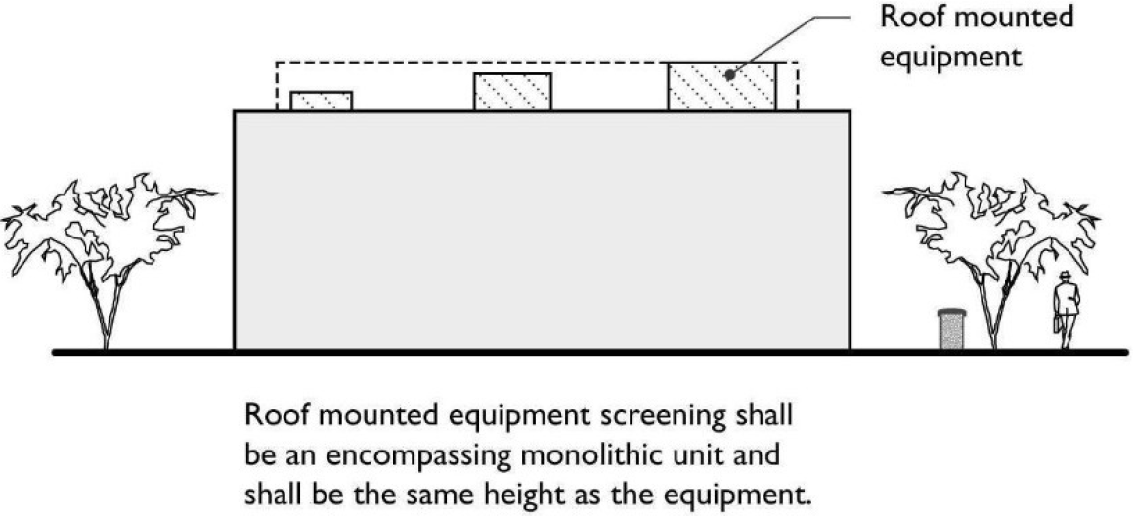

FIGURE 11-30-9.A.(1): SCREENING OF ROOF-MOUNTED EQUIPMENT
    - ROOF-MOUNTED SOLAR EQUIPMENT.
      - SOLAR EQUIPMENT PLACED ON FLAT ROOFS SHALL BE SCREENED A MINIMUM OF 60% OF THE HEIGHT OF THE EQUIPMENT.
      - ROOF-MOUNTED EQUIPMENT LAYING FLAT ON A SLOPED ROOF, WITHOUT ADDITIONAL STRUCTURES ELEVATING THE PANELS FROM COLLECTORS, DO NOT REQUIRE ANY ADDITIONAL SCREENING DEVICE.
24. Ground-Mounted Equipment. Ground-mounted equipment facing a Street or not otherwise separated from the Street by intervening building(s) shall be screened to a height of at least 12 inches above the equipment. Screening devices shall consist of decorative walls and/or berms (2:1 maximum slope) with supplemental plant materials including trees, shrubs and groundcovers. For screen walls that are 3 feet in height or lower, vegetative materials may be substituted for 50 percent of the Screening device.
A. GROUND-MOUNTED EQUIPMENT SHALL BE SCREENED TO A HEIGHT OF AT LEAST 12 INCHES ABOVE THE TALLEST PIECE OF EQUIPMENT.
B. SCREENING DEVICES SHALL CONSIST OF DECORATIVE WALLS AND/OR BERMS (2:1 MAXIMUM SLOPE) WITH SUPPLEMENTAL PLANT MATERIALS INCLUDING TREES, SHRUBS, AND GROUND COVERS.
C. VEGETATIVE MATERIALS MAY BE SUBSTITUTED FOR UP TO 50% OF THE SCREENING DEVICES WHEN USED IN CONJUNCTION WITH SCREEN WALLS THAT ARE THREE (3) FEET IN HEIGHT OR LOWER.
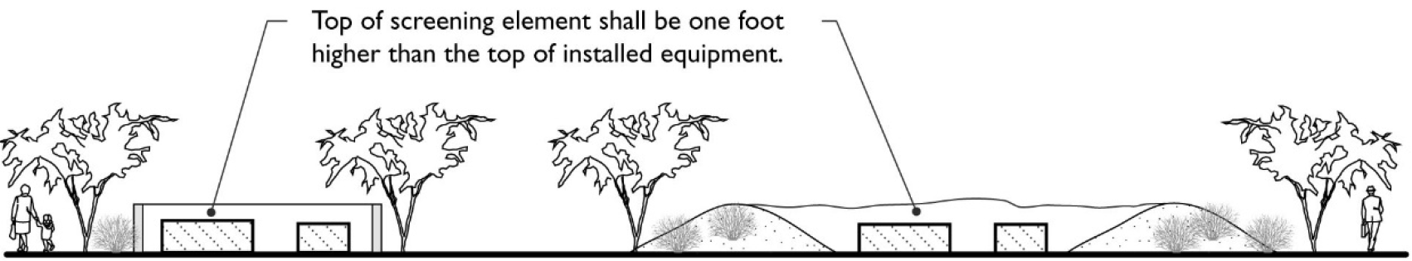
FIGURE 11-30-9.A.(2): SCREENING OF GROUND-MOUNTED
EQUIPMENT
35. Exterior Wall Equipment. Wall-mounted equipment, including but not limited to electrical meters, electrical distribution cabinets, service entry section (SES), fire sprinkler equipment and similar valves and cabinets that face a Street, or public parking and are not recessed and/or separated from the Street by intervening building(s) shall be screened. Screening devices shall incorporate elements of the building design, e.g. shape, color, texture and material. Vegetative materials may be substituted for up to 50 percent of the Screening devices when used in conjunction with screen walls that are 3 feet in height or lower.
A. SCREENING DEVICES FOR WALL-MOUNTED EQUIPMENT, INCLUDING BUT NOT LIMITED TO ELECTRICAL METERS, ELECTRICAL DISTRIBUTION CABINETS, SERVICE ENTRY SECTION (SES), FIRE SPRINKLER EQUIPMENT AND SIMILAR VALVES SHALL INCORPORATE ELEMENTS OF THE BUILDING DESIGN, E.G. SHAPE, COLOR, TEXTURE, AND MATERIAL.
B. VEGETATIVE MATERIALS MAY BE SUBSTITUTED FOR UP TO 50% OF THE SCREENING DEVICES WHEN USED IN CONJUNCTION WITH SCREEN WALLS THAT ARE THREE (3) FEET IN HEIGHT OR LOWER.
6. EXCEPTIONS. EXCEPTIONS TO THE SCREENING REQUIREMENTS MAY BE APPROVED BY THE ZONING ADMINISTRATOR WHEN IT CAN BE DEMONSTRATED THAT THE MECHANICAL EQUIPMENT WILL NOT BE VISIBLE FROM PUBLIC VIEW.
B. Truck Docks, Loading, and Service Areas. Truck docks, loading, delivery and service bays shall be screened according to the standards of Section 11-30-13.
C. Roof Access Ladders and Fire Sprinkler Risers. Design Objective: Reduce visual clutter at the skyline.The location of rRoof-access ladders and fire sprinkler risers shall be LOCATED within the interior of the structure.
D. Outdoor Storage. Screening for outdoor storage shall be according to the standards of Section 11-30-7, Outdoor Storage.
E. Drive-through Windows and Automated Car Washes. Design Objective: Reduce potential visual glare of headlights with screening that is an integral part of the site and landscaping theme.
Screening for vehicle lanes for drive-through windows and automated car wash openings shall be from public streets to a height of 40 inches. Screening devices shall consist of walls and/or berms with supplemental plant materials.
FE. AUTOMATED CAR WASH AND Auto Service Bays. Design Objective: Reduce view into open service bays, integrate screening device with project theme, and attenuate noise emanating from power-assisted tools.
1. Adjacent TO Residential or Mixed-use DEVELOPMENT. When the automobile/vehicle repair or service use is within 200 feet of a residential or mixed-use development without an intervening street, the followING standards shall apply along the common property line:
a. LOCATED WITHIN 100 FEET OF A RESIDENTIAL OR MIXED-USE DEVELOPMENT. Bay doors WHEN located within 100 feet of an adjacent residential or mixed-use development BAY DOORS AND OPENINGS shall be oriented away from the adjacentRESIDENTIAL OR MIXED-use.
b. LOCATED BETWEEN 100 TO 200 FEET OF RESIDENTIAL OR MIXED-USE DEVELOPMENT. WHEN Bay doors located between 100 feet and 200 feet of an adjacent residential or mixed-use development BAY DOORS AND OPENINGS SHALL BE and oriented such that the bay doors would be visible from the adjacent use shall be screened withBY an intervening building or an EIGHT (8’) FOOT tall screen wall.
c. LOCATED MORE THAN 200 FEET FROM A RESIDENTIAL OR MIXED-USE DEVELOPMENT. Bay doors WHEN located more than 200 feet from an adjacent residential or mixed-use development, and oriented such that the bay doors AND OPENINGS would be visible from the residential or mixed use development shall be screened by an intervening building or a SIX (6’) foot screen OPAQUE wall.
2. Screening from Adjacent Streets. Screening of bBay doorS AND openings shall be SCREENED FROM ADJACENT STREETS accomplished based uponBY ONE (1) OF the following METHODSpreferences:
a. INTERVENING BUILDINGS. BAY DOORS AND OPENINGS SHALL BE SCREENED FROM ADJACENT STREETS THROUGH THE The use of intervening buildings such that the bays doors are not visible from the street(s).
b. SETBACK 200 FEET OR GREATER. BThe bay doors AND OPENINGS are setback from the street a distance of 200 feet or greater.
c. ORIENT PERPENDICULAR TO THE STREET. Orient the bBuildingS SHALL BE ORIENTED SO such that the bay doors AND OPENINGS are perpendicular to the centerline axis of the abutting street. For corner lots, the bay doors shall be oriented perpendicular to the street with the highest functional classification identified in the Mesa Transportation Plan. In the event that the functional street classifications are equivalent, the orientation creating the smallest noise impact on adjacent residential development shall be used.
d. SETBACK LESS THAN 200 FEET TO THE STREET.When bBay doors AND OPENINGS THAT are less than 200 feet from an adjacent street and the bay doors AND OPENINGS are less than perpendicular to a street, screening shall be provided at leastBY A MINIMUM SIX (6) FOOT ' high OPAQUE WALL. Screening shall be at least 50% opaque and may include landscaping.
3. Landscape Screening. Large-canopy trees and shrubs shall be used to provide screening to the bay doors when the bays are visible from the adjacent street.
4. Noise Reduction. Air compressors and similar devices shall be housed in enclosed rooms designed to attenuate sound a minimum of 25 db.
G. Trash and Refuse Collection Areas. Design Objective: Reduce visual clutter of trash and refuse collection areas and integrate screening device with project theme.
Trash and refuse collection areas shall be screened so as to not be visible from a public street or parking area. Latching gates shall be provided for trash enclosure openings where visible from street and/or public parking areas. Orient openings away from public right-of-way, where possible. See Section 11-30-12.
HG. Parking Areas. Design Objectives: Reduce potential visual glare of headlights and reduce the visual clutter of parking fields with screening that is integral to the site and landscaping theme. Parking areas and drive aisles shall be screened from street(s) with masonry wall, berm or combination of walls/berms and densely planted landscaping or "vertical wire trellis panels". No more than 40 percent % of the screening shall be accomplished with dense landscaping.
1. Screen walls shall vary in height from 32 to 40 inches and shall be offset or staggered by at least 24 inches at intervals of no more than 50 feet.
2. The screening device shall vary in height from 12 to 18 inches when lawful display of automobiles, trucks, Recreational Vehicles, Manufactured Homes, boats, motorcycles, and utility trailers is adjacent to public streets.
3. Screen walls shall be composedCONSTRUCTED of HIGH-QUALITY, DURABLE MATERIALS SUCH AS STUCCO FINISH, TEXTURED BLOCK, brick, stone, DECORATIVE CAP BLOCK,stucco, or other SIMILAR HIGH-quality durable material that complements the theme of the project and shall include a decorative cap or top finish as well as edge detail at wall ends.
4. Berms shall be contoured and covered with a combination of vegetative and inert ground cover. If a contoured screening berm is installed, 24” INCH box trees may be substituted for required 36” INCH box trees.
5. Screen wall and/or berm height shall be measured from the finish grade of the parking lot.
6. When using a screen wall there shall be a landscaped setback of at least FIVE (5) feet between the screen wall and the edge of the parking area.
7. A setback of at least 10 feet shall be provided between the screen wall and the right-of-way.
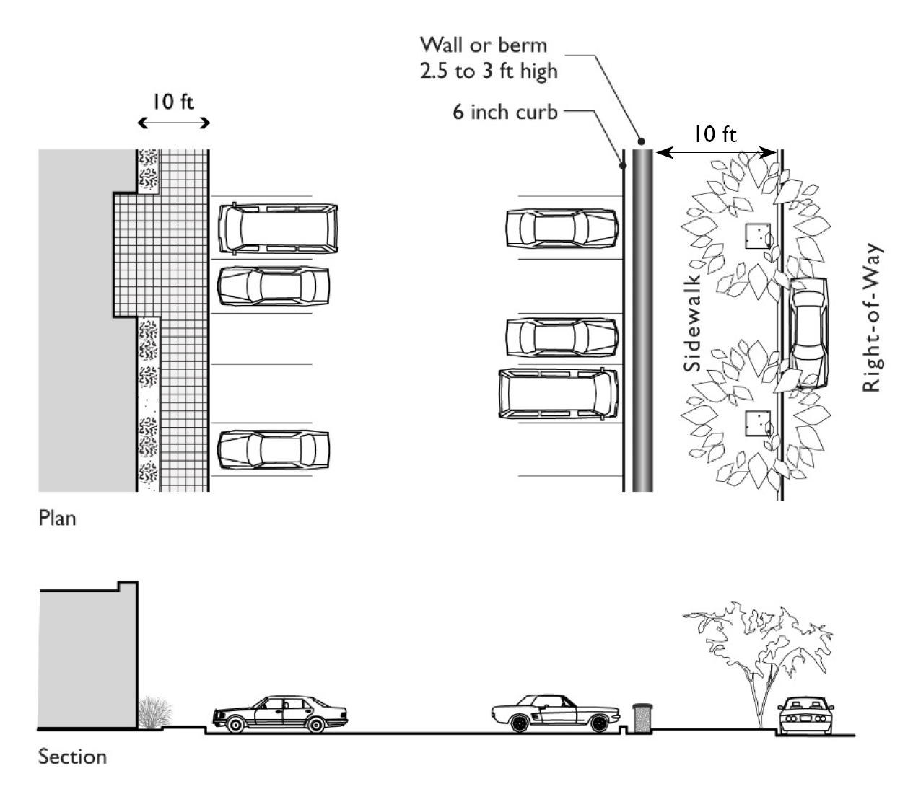
FIGURE 11-30-9.G(1): SCREENING AND SEPARATION OF PARKING AREA

IH. Common Property Lines. Design Objective: Fences and walls that screen building(s), facilities or activities of the site from adjacent development should be an effective buffer and an integral design component of the project.
A screening wall of SIX (6) feet in height shall be provided on the interior lot lines of any lot that contains any commercial use, industrial use, public or semi-public use (except Cemetery or Public Park and Recreation Facility), or transportation, communication and utilities use, as described in Chapter 86, Descriptions of Use Classifications and Use Types, and abuts a residential district or residential use. Such screening wall shall be provided at the rime TIME of new construction or expansion of buildings, or changes from one use classification to another non-residential use classification.
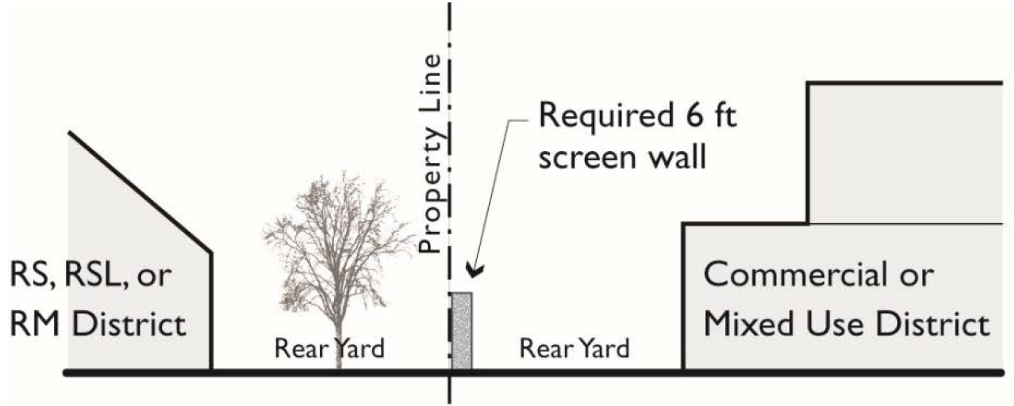
FIGURE 11-30-9.I: SCREENING ALONG RESIDENTIAL DISTRICT BOUNDARIES
1. Location. Screening walls shall follow the lot line of the lot to be screened, or shall be so arranged within the boundaries of the lot so as to substantially hide from adjoining lots the building, facility, or activity required to screened.
2. Materials. Industrial uses must provide a solid screening wall of stucco, decorative block, or concrete panel. Screening walls for other uses may be constructed of stucco, decorative block, concrete panel, or other substantially equivalent material. Chain-link fencing does not fulfill the screening wall requirement IS PROHIBITED.
3. Berms. A landscaped earth berm may be used in combination with, or in lieu of, the above types of screening walls.
4. Relationship to Fence and Wall Height Limits. If the minimum height required for screening walls exceeds the maximum permitted height of fences and freestanding walls for the zoning district, then an alternative screening solution shall be provided for review and approval by the Planning Director that meets the intent of the screening requirement.
5. Exception. In locations where commercial and multiple residence properties share a common interior property line the requirements for screening can be waived, except for loading and service areas, if the waiver of the screening will facilitate a more integrated design and development allowing greater pedestrian connection between the uses.
J. Roof-mounted Solar Equipment. Design Objective: Allow solar panels and other solar equipment to be placed on roofs in a manner that is aesthetically pleasing without creating excess shadows on the equipment.
Solar equipment placed on flat roofs shall be screened a minimum of 60% of the height of the equipment. Roof mounted equipment laying flat on a sloped roof, without additional structures elevating the panels from collectors do not require any additional screening device.
…
Section 25: That Mesa City Code Title 11 Section 11-30-10 is hereby amended as follows:

11-30-10: - SETBACKS AT INTERSECTIONS
A. Minimum Setback. Design Objective: Provide Open Space at intersections to enhance or establish distinctive locations.
Within the required Setbacks at intersections, integrate way-finding features CORNER TREATMENTS such as attractive plantings, pedestrian paving, lighting, monument signage and/or SStreet furniture SHALL BE PROVIDED WITHIN SETBACKS FROM THE INTERSECTION. All parking areas, and drive aisles shall be set back from SStreet intersections according to the standards in Table 11-30-10.

Table 11-30-10: Minimum Setbacks from Intersections
Intersections | Minimum Corner Setback (radius in feet)
 | DR, DB, DC, AND RM-5 and All Districts with a 'U' designator | All other non-residential districts
Arterial (110-130' R.O.W.) with Arterial | No radius is required for any of the above listed zoning districts so that the setback becomes an intersection of the street side setbacks with a build-to line where required. | Minimum 50' radius
Arterial with Major/Midsection Collector |  | Minimum 35' radius
Arterial with Major/Midsection Collector |  | Minimum 25' radius
Major/Midsection Collector (90—110' R.O.W.) with Major/Midsection Collector |  | Minimum 35' radius
Major/Midsection Collector with Collector/Industrial/Commercial |  | Minimum 25' radius
Collector/Industrial/Commercial (60—80' R.O.W.) with Collector/Industrial/Commercial |  | Minimum 25' radius

B. Landscaping. Corner Setbacks shall be landscaped according to the standards of Chapter 33, Landscaping.
…
Section 26: That Mesa City Code Title 11 Section 11-30-12 is hereby amended as follows:

11-30-12: - TRASH AND REFUSE COLLECTION AREAS
Design Objectives: Trash and refuse collection areas, including enclosures, should be an integral component of the project. The areas should be safe and convenient. The location should not be visually prominent.
A. General Applicability Requirements and Alternatives.
1. General Applicability Requirements. Solid waste and recycling-container enclosures are required for new dwelling groups consisting of FOUR (4) or more DDwelling UUnits and for all commercial or industrial developments in which the aggregate gross FFloor AArea exceeds 10,000 square feet. Designs must meet Mesa Standard Details.
2. Alternatives. Alternatives to standard requirements may be considered by the Planning Director and Solid Waste Management Director.
B. Location. All enclosures shall comply with all applicable Building and Fire Codes and shall meet the following requirements.
1. The solid waste and recycling storage area shall not be located within any required FFront Yards SETBACK, SStreet SSide Yard SETBACK, any required parking and landscaped areas, or any other area required by the Mesa City Code to be constructed and maintained unencumbered according to fire and other applicable building and public safety codes.
2. Solid waste and recycling areas shall be consolidated to minimize the number of collection sites and located so as to reasonably equalize the distance from the building spaces they serve.
3. Storage SOLID WASTE AND RECYCLING STORAGE areas shall be located so that the trucks and equipment used by the City of Mesa solid waste and recycling collector(s) have sufficient maneuvering areas.
C. Materials, Construction, and Design.
1. SCREENING REQUIRED. SOLID WASTE AND RECYCLING STORAGE AREAS SHALL BE FULLY SCREENED FROM PUBLIC STREETS AND PARKING AREAS.
12. Minimum Height of Screening. Solid waste and recycling storage areas located outside or on the exterior of any building shall be screened to a minimum height of SIX (6-) feet.
23. Enclosure Material. Enclosure material shall be solid masonry or concrete tilt- up with decorated exterior-surface finish compatible to the main structure(s).
34. Gate Material. Gate material shall be OPAQUE, decorative, AND CONSTRUCTED OF solid, heavy-gauge metal or a heavy-gauge metal frame with a covering of a view-obscuring material.
45. Access to Enclosure from Residential Projects. Each solid waste and recycling enclosure serving a residential project shall be designed to allow walk-in access without having to open the main enclosure gate.
56. Protection for Enclosures. Concrete curbs or equivalent shall protect enclosures from adjacent vehicle parking and travel ways.
67. Landscaping.
A. When feasible, the perimeter of the SOLID WASTE AND recycling and trash enclosure shall be planted with drought resistant LLandscaping, including a combination of shrubs and/or climbing evergreen vines.
B. TREES SHALL NOT BE PLANTED WITHIN TEN (10) FEET OF THE ENCLOSURE.
78. Lighting. All trash collection areas shall be well lit with a minimum ONE (1) foot candle.
…
Section 27: That Mesa City Code Title 11 Section 11-30-13 is hereby amended as follows:

11-30-13: - TRUCK DOCKS, LOADING, AND SERVICE AREAS
Design Objectives: Reduce the negative impact of noise and activity associated with truck docks, loading and service areas on quieter activities of adjacent properties. Minimize the impact of visual clutter associated with open bay doors and parked trucks being loaded and unloaded from adjacent lots and Street Rights-Of-Way.
ALL LOADING AND UNLOADING OF GOODS WHETHER FOR DELIVERY, STORAGE, SALE, OR OTHERWISE SHALL OCCUR WITHIN TRUCK DOCKS, LOADING, AND SERVICE AREAS. Truck docks, loading, and service areas shall be located and screened as follows:
A. Minimum Distance from Residential District. Truck docks, loading, and service areas are not permitted within 50 feet of the boundary of any residential district or use.
B. Location on Lot. In all districts except the GI, and HI Districts, truck docks, loading areas and service areas must be located at the rear or side of buildings, rather than facing a Street.
C. Screening. Truck docks, loading areas, and service areas located in any Zoning District shall be screened from any adjacent residential districts or uses. Docks, loading and service areas in any district except the GI and HI Districts shall be screened from public view. Screening shall consist of a solid masonry wall at least EIGHT (8) feet in height or opaque automated gates.
D. COMMERCIAL LOADING AND UNLOADING. IN THE DOWNTOWN BUSINESS, DOWNTOWN CORE, OR FORM BASED CODE DISTRICTS, THE LOADING AND UNLOADING OF COMMERCIAL VEHICLES SHALL OCCUR WITHIN 300 FEET OF THE SITE BEING SERVED.
…
Section 28: That Mesa City Code Title 11 Section 11-30-14 is hereby amended as follows:

11-30-14: - VISIBILITY AT INTERSECTIONS
Notwithstanding any other provisions of this section, no fence, wall, shrubbery, sign or other obstruction to vision between a height of THREE (3) feet and EIGHT (8) feet above the centerline grades of the intersecting streets shall be erected, placed, planted, allowed to grow or maintained within the triangular yard space formed by the intersecting center lines and a line joining points on such center lines 80 feet from the point of intersection. Where a conflict occurs between this requirement and the Subdivision LAND DIVISION Regulations, the more restrictive provision shall apply.
…
Section 29: That Mesa City Code Title 11 Section 11-31-3 is hereby amended as follows:

11-31-3: - ACCESSORY DWELLING UNIT
…
B. General Requirements.
1. There are no minimum lot size requirements to establish an ADU.
2. An ADU shall have a separate and independent entrance from the Primary Residence AND MAY NOT HAVE AN INTERNAL CONNECTION TO THE PRIMARY RESIDENCE.
…
D. Setbacks.
1. New Structures - Attached or Detached.
a. A minimum side and rear Setback of five (5) feet shall be provided for all side and rear Setbacks.
b. Front and secondary front (Street side) Setbacks shall comply with the Primary Residence Setback requirements for the underlying Zoning District.
C. ANY UNINHABITABLE SPACE (E.G., A GARAGE, UNCONDITIONED STORAGE ROOM, WORKSHOP, AND SIMILAR AREAS) ATTACHED TO AN ADU SHALL COMPLY WITH THE FOLLOWING:
        - FOR ATTACHED ADUS. UNINHABITABLE SPACE ATTACHED TO THE ATTACHED ADU SHALL COMPLY WITH THE SETBACK REQUIREMENTS FOR THE UNDERLYING ZONING DISTRICT.
        - FOR DETACHED ADUS. UNINHABITABLE SPACE ATTACHED TO THE DETACHED ADU SHALL COMPLY WITH THE SETBACK REQUIREMENTS FOR DETACHED ACCESSORY BUILDINGS OR STRUCTURES IN SECTION 11-30-17 OF THIS ORDINANCE.
  - Height. The height of an attached or detached ADU shall comply with the Primary Residence height requirements for the underlying Zoning District.
    - The height of an attached or detached ADU shall comply with the Primary Residence height requirements for the underlying Zoning District.
2. ANY UNINHABITABLE SPACE (E.G., A GARAGE, UNCONDITIONED STORAGE ROOM, WORKSHOP, AND SIMILAR AREAS) ATTACHED TO A DETACHED ADU SHALL COMPLY WITH THE HEIGHT REQUIREMENTS FOR DETACHED ACCESSORY BUILDINGS OR STRUCTURES IN SECTION 11-30-17 OF THIS ORDINANCE.
…
H. Utilities.
1. An ADU shall be provided with water, sewer, and electric utilities.
2. An ADU shall be served by the same water, sewer, and electric utility providers and meters as the Primary Residence.
3. An ADU may not be built on top of a current or planned public utility Easement of any kind unless the property owner receives written consent from any utilities currently using the public utility Easement or that may use the public utility Easement in the future.
…
Section 30: That Mesa City Code Title 11 Section 11-31-5 is hereby amended as follows:

11-31-5: - AUTOMOBILE RENTALS; AUTOMOBILE/VEHICLE SALES AND LEASING
…
D. Vehicle Display Platforms.
    - Elevated platforms or other structures or devices used for the display of vehicles associated with an approved vehicle sales or rental facility are permitted, provided such platforms, structures, or devices:
      - Shall only be located in areas currently approved or authorized for vehicle display; and
      - Shall not project into or over required landscape areas, drive aisles, or fire lanes; and
      - Shall not be located closer to the public Street than the existing, at-grade vehicle display area; and
      - Shall not exceed four feet (4') in height as measured from the mean finished grade of the display surface.
    - Only one (1) vehicle shall be displayed on each platform, structure, or device.
    - The number of display platforms, structures, or devices shall not exceed a ratio of one (1) per one hundred 100 feet (100') of lineal Street frontage of the at-grade display area (exclusive of driveways).
    - The Design Review Board PLANNING DIRECTOR may approve modifications or variations to the above provisions when such platforms, structures, or devices are a component of a site development plan reviewed and approved in accordance with Section 11-18-9 of this Title. Such modifications or variations shall only be approved upon a finding by the Board that such platforms, structures, or devicesCOMPLY WITH ALL OF THE FOLLOWING:
      - Constitute a design component, or incorporate architectural features, associated with the Primary Buildings or structures on the development site; and
      - Serve only to enhance the visibility of vehicles, and do not display or portray an advertising message, or commercial signage; and
      - Will not impede or obstruct the visibility of traffic maneuvering on the development site or traveling upon the public-Street; and
      - Incorporate increased Setbacks, enhanced LLandscaping, or other SScreening measures to effectively mitigate the impact of the platforms.
…
Section 31: That Mesa City Code Title 11 Section 11-31-7 is hereby amended as follows:

11-31-7: - AUTOMOBILE/VEHICLE WASHING
Automobile Washing, as described in Section 11-86-4, shall be located, developed, and operated in compliance with the land use regulations in Article 2 and the following standards:
A. Location. Automobile/Vehicle Washing, as a primary use, is only allowed on sites with at least one (1) frontage on an arterial street.
B. Setbacks. No building or structure shall be located within 20 feet of any interior lot line abutting a residential zoning district.
C. Drive-up Aisles and Required Queuing Area.
1. Drive-up aisles shall be at least 11 12 feet wide;
2. iIf adjacent to a street, the DRIVE-UP AISLEy shall be screened as specified in Section 11-30-9(EF), Drive-through Windows and Automated Car Washes AND AUTO SERVICE BAYS.
3. The drive-up aisle shall provide queuing space, with no encroachment into required landscape areas or building setbacks, for at minimum:
1A. FOUR (4) vehicles per pull-through rack for each automatic wash bay.
2B. THREE (3) vehicles per bay for self-serve, coin-operated and/or hand wash facilities.
D. Landscaping. WHEN Automobile/Vehicle Washing, as aIS THE primary use ON A SITE, in addition to perimeter, parking lot, and foundation base landscaping requirements, landscaping shall comprise a minimum of 10 percent% of the site area.
E. Litter. One (1) permanent, non-combustible trash receptacle per wash bay is required.
F. Noise.
1. Sound attenuating measures shall be incorporated into the building design and construction to absorb noise such that the sound level readings at the street and at interior property lines are no more than 55 decibels.
2. Mechanical equipment for centralized vacuum equipment shall be housed in an enclosed room.
G. Additional Special Use Permit Criteria. When a Special Use Permit is required, THE APPROVING BODY SHALL FIND THAT THE PROJECT COMPLIES WITH ALL OF THE FOLLOWINGby Article 2, each of the following items shall be included in the evaluation:
1. The number of automobile related activities within 600-feet of an intersection of arterial streets shall not exceed two (2), including aAutomobile/vVehicle wWashing, aAutomobile sService sStations, aAutomobile sSales or rRental lLots, or aAutomobile/vVehicle rRepair.
2. Proposed locations within "-U" designated areas shall be oriented with canopies CANOPIES and fuel dispensing equipment ARE ORIENTED away from the street, either to the side or to the rear of a THE building.
3. Compliance with all development standards for the applicable zoning district, including compliance with all requirements for automobile related services located in all mixed districts and "-U" designated districts.
4. The use is found to be inPROJECT compliance COMPLIES with the General Plan, applicable Sub Area Plans, and ANY other recognized development APPLICABLE pPlans AND/or policies, and will be compatible with surrounding uses; and.
5. Evidence that acceptable documentation is present demonstrating that the building or site proposed for the useTHE PROJECT shallIS DESIGNED TO:
A. adequately pProvide paved parking and on-site circulation in a manner that minimizes impacts on adjacent sites; and
B. existing or proposed improvements to the site shall mMinimize dust, fugitive light, glare, noise, offensive smells, and traffic impacts on neighboring residential sites.
6. A finding that a Pplan of Ooperation has been submitted, which includes, but is not limited to, acceptable evidence of compliance with all zoning, building, and fire safety regulations; and.
7. A finding that a "Ggood Nneighbor Ppolicy" in narrative form has been submitted, which includes, but is not limited to, descriptions of acceptable measures to ensure ongoing compatibility with adjacent uses, including sound attenuation, lighting control measures, and vehicular access and traffic control. Such policies shall include, but are not limited to:
A. Tthe name and telephone number of the position, manager or person responsible for the operation of the facility;
B. Ccomplaint response procedures, including investigation, remedial action, and follow-up; and
C. Llitter control measures; and.
8. Evidence that acceptable documentation is present demonstrating that the building or site proposed for the use is in, or will be brought into, substantial conformance with all current City Development Standards, including, but not limited to, landscaping, parking, screen walls, signage, and PROJECT-SPECIFIC design guidelines.
…
Section 32: That Mesa City Code Title 11 Section 11-31-9 is hereby amended as follows:

11-31-9: - COMMERCIAL USES IN ANY RESIDENCE RESIDENTIAL DISTRICTS
…
A. Applicable Policies. The use is found to be in compliance with the General Plan, and with applicable Sub-Area Plans, Neighborhood Plans and other recognized development plans or policies, and will be compatible with surrounding uses; and
1. SiteDEVELOPMENT Plan. A finding that an acceptable siteDEVELOPMENT plan has been submitted for review and consideration.
…
Section 33: That Mesa City Code Title 11 Section 11-31-16 is hereby amended as follows:

11-31-16: - LARGE COMMERCIAL DEVELOPMENT
Large Commercial Development, as described in Section 11-86-4, buildings shall be located, developed and operated in compliance with the land use regulations in Article 2, and the following standards:
A. Section 11-CHAPTER 6 -3 Standards Apply. IN ADDITION TO THE REQUIREMENTS BELOW, Large Commercial Development shall comply with all requirements of Section 11-6-3 (DEVELOPMENT STANDARDS) AND SECTION 11-6-4 (SITE PLANNING AND DESIGN STANDARDS), without regard to minimum floor area requirements.
B. Customer Entrances. All BUILDING entries designed for general public and customer access to the building shall BE CLEARLY DISTINGUISHABLE FROM THE REMAINDER OF THE BUILDING AND INCORPORATE ONE (1) OR MORE OF THE FOLLOWING DESIGN ELEMENTS:
1. Be clearly visually distinctive from the remainder of the building, and be readily visible from the public Street; THE FAÇADE SHALL BE ARTICULATED AT LEAST 10 FEET HORIZONTALLY AND FOUR (4) FEET VERTICALLY FOR THE FULL HEIGHT OF THE ENTRY FEATURE;
2. Include an extended foundation base to provide a customer drop-off area of a minimum 900 square feet, extending a minimum 20-feet measured perpendicular from the public entrance door. See Figures 11-31-16.B.2 and 11-31-16.B.2.2; and THE ENTRYWAY SHALL CONTAIN A MINIMUM 75% GLAZING.
3. Comply with the requirements of Section 11-30-8, Pedestrian Connections and Section 11-32-4(G)3, Pedestrian Access regarding all pedestrian connections within parking areas to other buildings on site, to the public Street, and to transit stops or stations. THE ENTRYWAY SHALL BE DEFINED BY A DISTINCT CHANGE IN BUILDING MATERIAL;
4. THE ENTRYWAY SHALL INCLUDE A DISTINCT CHANGE IN ROOF FORM (E.G., CURVILINEAR VERSUS FLAT PARAPET, TOWER FEATURE, ANGLED VERSUS FLAT, ETC.); OR
5. OTHER ARCHITECTURAL FEATURES AS APPROVED BY THE PLANNING DIRECTOR.
C. ENTRYWAY MONUMENTATION FEATURE. EACH LARGE COMMERCIAL DEVELOPMENT SHALL PROVIDE AT LEAST ONE (1) ENTRYWAY MONUMENTATION FEATURE AT A PRIMARY DRIVEWAY SERVING AN ARTERIAL OR COLLECTOR STREET. THE ENTRYWAY MONUMENTATION FEATURE SHALL CONSIST OF:
1. A LANDSCAPED MEDIAN MEASURING AT LEAST SEVEN (7) FEET IN WIDTH;
2. A LANDSCAPED ROUNDABOUT;
3. AN ARCHITECTURAL GATEWAY (E.G., PAIRED COLUMNS WITH OVERHEAD ELEMENT); OR
4. OTHER FEATURE(S) APPROVED BY THE PLANNING DIRECTOR.

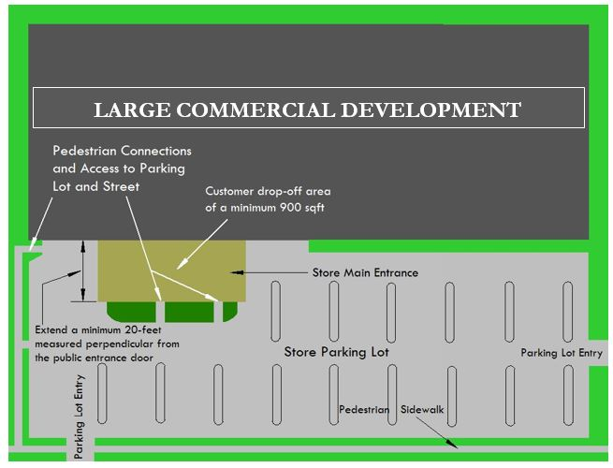

FIGURE 11-31-16.B.2: STORE BUILDING ENTRIES

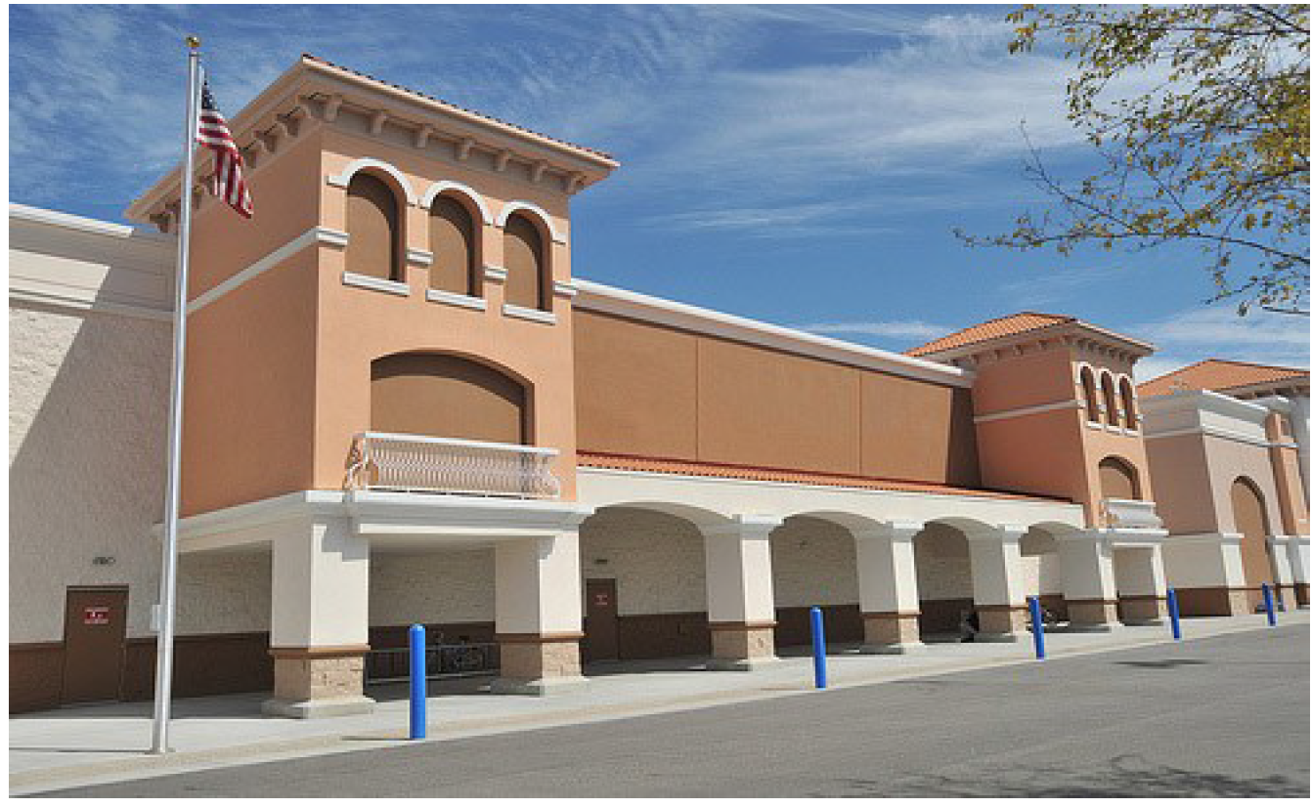

FIGURE 11-31-16.B.2.2: STORE ENTRIES
C. Large Commercial Development in "-U" Designated Areas. In addition to the development standards specified in Section 11-6-43, Large Commercial Development buildings located in "-U" designated areas shall comply with the following requirements:
1. Number of Store Entries. Buildings greater than 200-feet wide shall provide a minimum of 2 public entries to the store building. Store buildings greater than 300-feet wide shall provide public entries from the street at a ratio of 1 entry for every 150 linear feet of building width. Public entries shall have a minimum separation of 50-feet between entries.
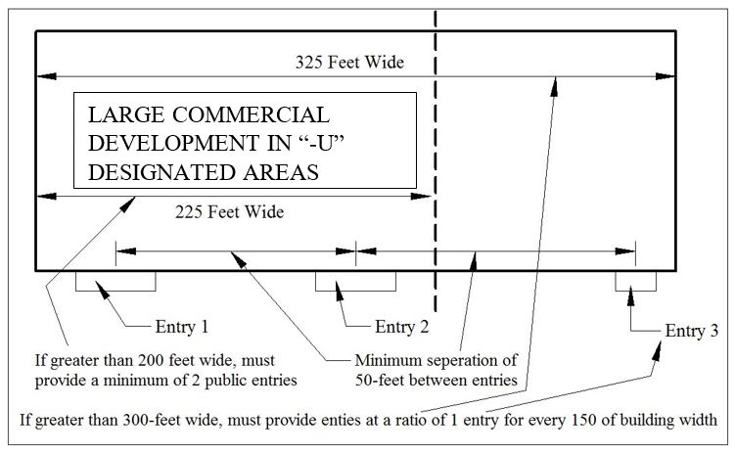

FIGURE 11-31-16.C.1: NUMBER OF STORE ENTRIES
2. Maximum Setback Standard. The ground level of a building or buildings shall be placed no further back than the maximum setback for a minimum of 65 percent of the width of the building.
3. Corner Properties. Where a property fronts on 2 or more streets, the building shall be placed at the maximum setback or closer to the street right-of-way on 2 sides for at least 65 percent of the building width on one street side, and for 50 percent of the building width on the second side. For lots fronting more than 2 streets, this requirement shall be met along the frontage of the two streets with the highest functional classification identified in the Mesa Transportation Plan. If all streets adjacent to the property have the same functional classification, the developer shall choose which 2 street frontages apply.
D. ENTRYWAY PLAZAS. AN ENTRYWAY PLAZA SHALL BE PROVIDED AT THE ENTRY TO EACH ANCHOR TENANT BUILDING.
    - MINIMUM SIZE. THE ENTRYWAY PLAZA SHALL HAVE A MINIMUM AREA OF 900 SQUARE FEET AND EXTEND AT LEAST 20 FEET, PERPENDICULAR FROM THE PUBLIC ENTRANCE.
    - DESIGN ELEMENTS. THE ENTRYWAY PLAZA SHALL INCLUDE DECORATIVE PAVING, SEATING AREAS, RAISED PLANTERS, OR TREES.
E. OPEN SPACE. OPEN SPACE SHALL BE PROVIDED AS FOLLOWS:
1. MINIMUM AREA.
A. FIVE (5) SQUARE FEET PER 1,000 SQUARE FEET OF BUILDING GROSS FLOOR AREA SHALL BE PROVIDED FOR OPEN SPACE.
B. EACH AREA DESIGNATED AS OPEN SPACE SHALL BE NO LESS THAN 200 SQUARE FEET IN AREA.
C. REQUIRED SIDEWALKS SHALL NOT BE INCLUDED IN THE OPEN SPACE CALCULATION.
2. LOCATION.
A. REQUIRED OPEN SPACE SHALL BE VISIBLE FROM A PUBLIC STREET, OR FROM ON-SITE AREAS NORMALLY FREQUENTED BY CUSTOMERS.
B. REQUIRED OPEN SPACE SHALL BE ACCESSIBLE DURING BUSINESS HOURS.
C. ENTRYWAY PLAZAS AND AREAS DESIGNATED FOR CUSTOMERS TO WAIT FOR RIDESHARE SERVICES MAY BE COMBINED WITH REQUIRED OPEN SPACE.
3. SHADE.
A. REQUIRED. AT LEAST 50% OF THE REQUIRED OPEN SPACE SHALL BE SHADED BY TREES, SHADE STRUCTURES, OR OTHER PERMANENT ELEMENTS INTEGRATED INTO THE SITE DESIGN.
B. MEASURING SHADE. SHADE COVERAGE SHALL BE MEASURED AT 3:00 P.M. ON THE SUMMER SOLSTICE AND VERIFIED THROUGH A SHADOW STUDY. FOR THE PURPOSE OF SHADE CALCULATIONS, TREE CANOPIES SHALL BE EVALUATED BASED ON THEIR PROJECTED GROWTH FIVE (5) YEARS AFTER PLANTING.
4. AMENITIES. REQUIRED OPEN SPACE SHALL INCLUDE AMENITIES, IN ADDITION TO REQUIRED SHADE ELEMENTS. AMENITIES MAY INCLUDE SEATING AREAS; WATER AND COOLING FEATURES (E.G., DRINKING FOUNTAINS, SPLASH PADS, ETC.); PLAY, FITNESS, AND RECREATION EQUIPMENT; MOBILITY STATIONS (E.G., BIKE REPAIR STATION, MICROMOBILITY DOCKS, WAYFINDING KIOSKS/MAPS); POP-UP/ACTIVATION SPACE (E.G. PERFORMANCE STAGE, STUBS OUTS FOR ELECTRIC, WATER, ETC.); PUBLIC ART; OR OTHER AMENITIES AS DETERMINED BY THE PLANNING DIRECTOR TO PROVIDE EQUIVALENT FUNCTIONAL OR RECREATIONAL VALUE.
DF. Criteria for Review of Council Use Permit. When required, the review of the A Council Use Permit IS REQUIRED, CITY COUNCIL SHALL FIND THE PROJECT COMPLIES WITH for a Large Commercial Development shall include a review and determination regarding ALL OF the following items:
1. The use is found to be in PROJECT compliance COMPLIES with the General Plan, applicable Sub Area Plans, and ANY other recognized development APPLICABLE Pplans AND/or policies, and will be compatible with surrounding uses; and.
2. A finding that a pPlan of oOperation has been submitted, which includes, but is not limited to, acceptable evidence of compliance with all zoning, building, and fire safety regulations; and.
3. A finding that a "gGood nNeighbor pPolicy" in narrative form has been submitted, which includes, but is not limited to, descriptions of acceptable measures to ensure ongoing compatibility with adjacent uses, including sound attenuation, lighting control measures, and vehicular access and traffic control. Such policies shall include, but are not limited to:
A. tThe name and telephone number of the position, manager or person responsible for the operation of the facility;
B. cComplaint response procedures, including investigation, remedial action, and follow-up; and
C. lLitter control measures; and.
4. Evidence that acceptable documentation is present demonstrating that the building or site proposed for the use is in, or will be brought into, substantial conformance with all current City Development Standards, including, but not limited to, landscaping, parking, screen walls, signage, and PROJECT-SPECIFIC design guidelines.
5. Evidence that acceptable documentation is present demonstrating that the building or site proposed for the use shall adequately provide paved parking and on-site circulation in a manner that minimizes impacts on adjacent sites; and existing or proposed improvements to the site shall minimize dust, fugitive light, glare, noise, offensive smells and traffic impacts on neighboring residential sites. THE PROJECT IS DESIGNED TO:
A. PROVIDE PAVED PARKING AND ON-SITE CIRCULATION IN A MANNER THAT MINIMIZES IMPACTS ON ADJACENT SITES; AND
B. MINIMIZE DUST, FUGITIVE LIGHT, GLARE, NOISE, OFFENSIVE SMELLS, AND TRAFFIC IMPACTS ON NEIGHBORING RESIDENTIAL SITES.
…
Section 34: That Mesa City Code Title 11 Section 11-31-18 is hereby amended as follows:

11-31-18: - DRIVE-THRU AND PICK-UP WINDOW FACILITIES
…
D. Stacking Requirements.
…
5. Modifications to Stacking Requirements. Modifications to the stacking requirements found in this Section may be approved through the siteDEVELOPMENT pPlan rReview process if the Planning Director or their designee determines, based on the Onsite Circulation and Stacking Study, that the proposed modifications to the stacking requirements are sufficient to meet the demands of the development, including the traffic circulation, and stacking demands.
…
Section 35: That Mesa City Code Title 11 Section 11-31-19 is hereby amended as follows:

11-31-19: - OUTDOOR EATING AREAS
Outdoor eEating aAreas in conjunction with an eEating and dDrinking eEstablishment, as described in Section 11-86-4, shall be located, developed, and operated in compliance with the land use regulations in Article 2 and the following standards:
A. Downtown Core, AND Form Based Code Transect DISTRICTS, Commercial District with a "-U" Designation.
1. Location. Within the Downtown Core District (DC), AND Form Based Code Transect Districts, and any Commercial District with a "-U" Designation, an Outdoor Eating Area is permitted only in the following locations:
a. Within the buildable area of the lot; or
b. Within the right-of-way, on a public sidewalk, provided a minimum six (6) foot wide contiguous portion of the public sidewalk remains unobstructed for pedestrian use. Review and approval of an encroachment permit by the City Engineer is required for any Outdoor Eating Area located on a public sidewalk.
…
Section 36: That Mesa City Code Title 11 Section 11-31-20 is hereby amended as follows:

11-31-20: - OUTDOOR DISPLAY
…
D. Hours of Operation. Outdoor displays may only operate during the hours of operation of the primary business. All structures, signs, equipment, and displays associated with an outdoor display must be stored indoors at all times when the primary business is closed to the public, unless the outdoor display is permitted as a permanent location on an approved siteDEVELOPMENT plan.
…
Section 37: That Mesa City Code Title 11 Section 11-31-22 is hereby amended as follows:

11-31-22: - PLACES OF WORSHIP
Places of Worship, as described in Section 11-86-4, shall be located, developed, and operated in compliance with the land use regulations in Article 2 and the following standards:
A. Accessory Uses. Accessory uses customarily found in conjunction with Places of Worship, including parish houses, parsonages, rectories, seminaries, classrooms, and convents, are permitted, provided that such accessory uses are located on the same lot or contiguous lot with the religious facility.
B. Athletic Facilities and Day Care Centers. Athletic facilities and day care centers in conjunction with Places of Worship require approval of a Special Use Permit.
C. Residential Districts. Places of Worship located in residence districts shall:
1. Locate buildings within the required setbacks for the building setbacks specified for that zoning district; AND
2. Comply with DEVELOPMENT AND DESIGN design standards for the LC dDistrict, unless located within an area designated by the U Character Designator, when it would then comply with LC- U design standards.
D. Building Setback, Building Height, Parking, Landscaping and Screening Standards. Places of Wordship shall comply with each of the following:
1. The building setback and building height requirements established by the zoning district for which the Places of Worship is located; unless modified as a building height exception pursuant to Section 11-30-3.
2. Landscaping and SScreening requirements as specified for a LC development, pursuant to Section 11-30-9 and Chapter 33. In the event character designators "-U" or "-A" are established for the Places of Worship site, the development standards associated with such character designators shall also apply. site, the development standards associated with such character designators shall also apply.
3. All parking requirements specified in Chapter 32.
…
Section 38: That Mesa City Code Title 11 Section 11-31-24 is hereby amended as follows:

11-31-24: - SCHOOLS
…
B. Building Setback, Building Height, Parking, Landscaping and Screening Standards. Schools shall:
1. Comply with the building setback and building height requirements established by the zoning district for which the School is located; unless modified as a building height exception pursuant to Section 11-30-3;
2. Comply with Landscaping LANDSCAPING and SScreening requirements as specified for a LC development, pursuant to Chapters 6SECTION 11-30-9 and Chapter 33; and
3. Comply with all parking requirements specified in Chapter 32.
4. In the event the school is located in a Downtown, Mixed or "-U" designated district, Section 11-6-4, Special Standards for Districts with "-U" Character Designator shall apply rather than Section 8-6-3
…
Section 39: That Mesa City Code Title 11 Section 11-31-25 is hereby amended as follows:

11-31-25: - SERVICE STATIONS
…
H. Urban Character Designator Design Standards. When located in a "-U" designated district, the main structure containing the office, cashier, retail shop and/or other services shall be placed between the pump canopy and the street right-of-way no further back from the property line than the maximum setback. When located on a corner, the street with the higher functional classification shall be used to determine compliance with this requirement.
IH. Criteria for Review of Special Use Permit. When required, the review of the A Special Use Permit IS REQUIRED for a Service Station, THE APPROVING BODY shall include a review and determination regarding the FIND THAT THE PROJECT CONFORMS TO ALL OF THE following items:
1. The use is found to be in PROJECT compliance COMPLIES with the General Plan, applicable Sub Area Plans, and ANY other recognized development APPLICABLE pPlans AND/or policies, and will be compatible with surrounding uses; and.
2. A finding that a pPlan of oOperation has been submitted, which includes, but is not limited to, acceptable evidence of compliance with all zoning, building, and fire safety regulations; and.
3. A finding that a "gGood nNeighbor pPolicy" in narrative form has been submitted, which includes, but is not limited to, descriptions of acceptable measures to ensure ongoing compatibility with adjacent uses, including sound attenuation, lighting control measures, and vehicular access and traffic control. Such policies shall include, but are not limited to:
A. tThe name and telephone number of the position, manager or person responsible for the operation of the facility;
B. cComplaint response procedures, including investigation, remedial action, and follow-up; and
C. lLitter control measures; and.
4. Evidence that acceptable documentation is present demonstrating that the building or site proposed for the use is in, or will be brought into, substantial conformance with all current City Development Standards, including, but not limited to, landscaping, parking, screen walls, signage, and PROJECT-SPECIFIC design guidelines.
5. Evidence that acceptable documentation is present demonstrating that the building or site proposed for the use shall adequately provide paved parking and on-site circulation in a manner that minimizes impacts on adjacent sites; and existing or proposed improvements to the site shall minimize dust, fugitive light, glare, noise, offensive smells and traffic impacts on neighboring residential sites.THE PROJECT IS DESIGNED TO:
A. PROVIDE PAVED PARKING AND ON-SITE CIRCULATION IN A MANNER THAT MINIMIZES IMPACTS ON ADJACENT SITES; AND
B. MINIMIZE DUST, FUGITIVE LIGHT, GLARE, NOISE, OFFENSIVE SMELLS, AND TRAFFIC IMPACTS ON NEIGHBORING RESIDENTIAL SITES.
…
Section 40: That Mesa City Code Title 11 Section 11-31-31 is hereby amended as follows:
11-31-31: - RESIDENTIAL USES IN COMMERCIAL DISTRICTS
…
D. Projects that comply with the residential density maximums specified in Table 11-6-3.A, and the commercial Floor Area requirements in Section 11-31-31(A)(1) above require SiteDEVELOPMENT Plan Review, as described in Chapter 69.
…
Section 41: That Mesa City Code Title 11 Section 11-32-3 is hereby amended as follows:

11-32-3: - PARKING SPACES REQUIRED
…
F. Credit for On-Street Spaces. On-street parking spaces located immediately adjacent to the frontage of properties in the EO, MX, DB, and DC dDistricts or districts with a "-U" designator, may be counted toward required off-street parking for non-residential uses. One (1) on-street parking space may be substituted for each required off-street space. These provisions only apply to street frontages where on-street parking is allowed and provided. The parking space credit shall be determined at the time of siteDEVELOPMENT plan approval.
G. Uses not Specified. The parking requirement for any use not listed in Table 11-32-3(A) shall be determined by the Zoning Administrator based upon the requirements for the most similar comparable use, the particular characteristics of the proposed use, and any other relevant data regarding parking demand. In order to make this determination, the Zoning Administrator may require the applicant to submit a parking demand study or other information, at the applicant's cost.
H. Credit for On-Street Spaces. On-street parking spaces immediately adjacent to the frontage of properties in the EO, ME, PE, and DC districts or districts with a "-U" designator, may be counted toward required off-street parking for non-residential uses. One on-street parking space may be substituted for each required off-street space. These provisions only apply to street frontages where on-street parking is allowed and provided. The parking space credit shall be determined at the time of site plan approval.
…
Section 42: That Mesa City Code Title 11 Section 11-32-4 is hereby amended as follows:

11-32-4: - PARKING AREA DESIGN
…

G. Circulation and Safety.
1. Internal VEHICULAR Circulation.
a. Visibility shall be assured for pedestrians, bicyclists, and motorists entering individual parking spaces, circulating within a parking facility, and entering or leaving a parking facility.
b. Internal circulation patterns, and the location and traffic direction of all access drives, shall be designed and maintained in accordance with accepted principles of traffic engineering and traffic safety SHALL BE DESIGNED TO FACILITATE THE SAFE MOVEMENT OF VEHICLES WITHOUT POSING A DANGER TO PEDESTRIANS OR IMPEDING THE FUNCTION OF THE PARKING AREA.
C. PARKING LOTS THAT ACCOMMODATE 10 OR MORE VEHICLES MUST MAINTAIN CONTINUOUS CIRCULATION PATTERNS, WITH NO DEAD ENDS, AND SAFE ACCESS TO PUBLIC STREETS.

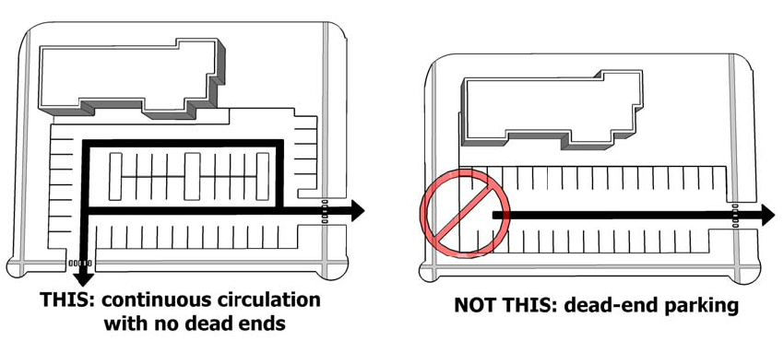
FIGURE 11-32-4.G(1): VEHICULAR CIRCULATION DESIGN

cD. Off-street parking and loading areas shall be provided with sufficient maneuvering room so that all vehicles can enter and exit from a public street by forward motion only. This regulation does not apply to parking areas serving Single-Family Residences served by individual driveways. The maneuvering of vehicles necessary to enter or exit loading areas shall not occur on City streets.
dE. Parking lots shall be designed so that solid waste, emergency, and other public service vehicles can provide service without backing unreasonable distances UP MORE THAN 50 FEET or making other dangerous or hazardous turning movements.
2. Parking Lot Layout.
A. No more than 200 parking spaces shall be allowed LOCATED together in one (1) group or cluster, . Parking lot clustersshall be separated by landscaping, pedestrian connections, cross aisles, retention basins, or similar features.
B. PARKING LOT CLUSTERS SHALL BE SEPARATED FROM OTHER GROUPS OR CLUSTERS BY A 15-FOOT WIDE LANDSCAPED FEATURE, CROSS AISLES, RETENTION BASINS, OR SIMILAR FEATURES.
a. In office-use and industrial projects, a minimum 25 percent of the required parking spaces shall be provided within 200 feet of the building served, with the balance of the required parking within 400 feet.
b. In commercial and mixed-use projects, a minimum of 50 percent of the required parking spaces shall be located within 300 feet of the building served.
c. In residential projects, required parking spaces shall be arranged to provide at least one parking space per unit within 200 feet of the dwelling units they are intended to serve.
dC. Drive aisle intersections are toSHALL be perpendicular to each other.
eD. Separate vehicular and pedestrian circulation systems shall be provided.

3. Pedestrian Access. Design Objective: Provide a safe, convenient and comfortable network of pedestrian walkways within parking areas for users and residentsThe design standards described below shall be provided for multi-family residential developments of 5 or more units and for commercial, mixed-use, and/or industrial developments that are 80 feet or more in depth and/or include 50 or more parking spaces.
a. Pedestrian Safety. Parking lot design should be laid out in a way to minimize the times pedestrians would typically have to walk between parked cars and then cross a drive aisle to get to locations on the site. Internal circulations systems shall be clearly defined.

      - Materials and Width. Walkways shall provide at least 5 feet of unobstructed width and be hard-surfaced with a material that differs from the drive aisle by composition, texture, or through the use of a differing color that is integral to the material.
A. PEDESTRIAN WALKWAYS SHALL BE AT LEAST FIVE (5) FEET IN WIDTH AND PAVED WITH A HARD SURFACE.
B. PARKING LOTS CONTAINING MORE THAN 200 PARKING SPACES SHALL PROVIDE PEDESTRIAN WALKWAYS THROUGH THE PARKING FIELD.
C. FOR PARKING ROWS PERPENDICULAR TO THE PRINCIPAL BUILDING FACADE, PEDESTRIAN WALKWAYS SHALL BE LOCATED BETWEEN TWO (2) ROWS OF PARKING SPACES AT A MINIMUM OF ONE (1) PEDESTRIAN WALKWAY EVERY 200 FEET.
D. FOR PARKING ROWS PARALLEL TO THE PRINCIPAL BUILDING FAÇADE, PEDESTRIAN WALKWAYS SHALL BE PROVIDED THROUGH THE PARKING ROWS AT A MINIMUM OF ONE (1) PEDESTRIAN WALKWAY EVERY 21 PARKING SPACES, AND SUCH WALKWAYS SHALL BE LOCATED IN CONJUNCTION WITH REQUIRED LANDSCAPE ISLANDS.
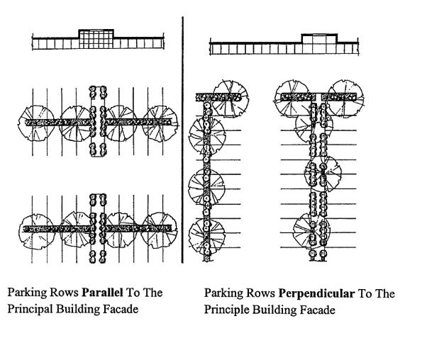
FIGURE 11-32-4.G(2): PARKING ROW ORIENTATION

cE. IdentificationPedestrian walkways shall be clearly differentiated from driveways, parking aisles, and parking and loading spaces through the use of elevation changes, a different paving material, or similar method. Where a pedestrian sidewalk WALKWAY crosses a vehicle lane, the pedestrian sidewalk WALKWAY shall be raised a minimum of THREE (3) inches above the vehicle lane and made distinct by use of textured paving, PAVEMENT MARKINGS, OR and contrasting color.
dF. Separation. Where a pedestrian walkway is parallel and adjacent to an auto travel lane, it must SHALL be raised and separated from the auto travel lane by a raised curb at least SIX (6) inches high, decorative bollards, or other physical barrier.
…
Section 43: That Mesa City Code Title 11 Section 11-32-5 is hereby amended as follows:

11-32-5: - SHARED PARKING
…
  - Authorization and Criteria.
…

3. Application Requirements. A request for approval of a shared parking arrangement must be accompanied by such information determined by the Zoning Administrator to be necessary to evaluate the peak parking demand characteristics or difference in hours and/or days of operation, including, but not limited to, a description of the uses and their operational characteristics, a siteDEVELOPMENT plan including a description of pedestrian access, and a parking study prepared by a licensed professional traffic engineer or equivalent qualified professional which justifies the reduction in parking requested.
…
Section 44: That Mesa City Code Title 11 Section 11-32-7 is hereby amended as follows:

11-32-7: - ALTERNATIVE COMPLIANCE WITH MINIMUM PARKING REQUIREMENTS
A. Authorized Alternatives. The Zoning Administrator is authorized toMAY approve AN alternative compliance parking PLANpermits for the following:
1. Off-site parking (See C, below);
2. Valet parking (See D, below);
3. HIGH-CAPACITY TTransit accessibility (See E, below);
4. Residential RESIDENTS WITH SSpecial NNeeds (See F, below); and
5. Community building(s) for residential developments (See G, below).
B. Special ADMINISTRATIVE Use Permit Required. Applicants seeking approval of an alternative compliance parking plan must secure approval of aN Special ADMINISTRATIVE Use Permit, pursuant to Chapter 70.
C. Off-Site Parking. The Zoning Administrator may permit all or a portion of the required off-street parking spaces to be located on a remote and separate lot from the lot on which the principal use is located, subject to the standards of this Section.
1. Location.
A. No off-site parking space may be located more than 1,000 feet from the primary entrance of the use served, measured along the shortest legal, practical walking route.
B. This distance limitation may be waived by the Zoning Administrator if adequate assurances are offered that van or shuttle service will be operated between the off-site parking areas and the principal use.
2. Off-Site Parking Agreement. An agreement providing for the use of off-site parking, executed by the parties involved, must be filed with the Zoning Administrator, in an approved form. Off-site parking privileges will continue in effect only as long as the agreement, binding on all parties, remains in force. Agreements must guarantee long-term availability of the parking, commensurate with the use served by the parking, and shall be recorded with the County Recorder's Office. If an off-site parking agreement lapses or is no longer valid, then parking must be provided as otherwise required by this Chapter. AVAILABILITY. THE APPLICANT SHALL DEMONSTRATE THROUGH A PARKING ANALYSIS THAT ONE OF THE FOLLOWING CRITERIA IS MET.
A. THE EXISTING NUMBER OF PARKING SPACES ON THE REMOTE LOT MEETS THE MINIMUM PARKING REQUIREMENTS FOR THE USES ONSITE, AS WELL AS THE MINIMUM REQUIREMENTS FOR THE PORTION OF THE USE PROPOSED TO BE ACCOMMODATED OFF-SITE; OR
B. A PARKING DEMAND STUDY DEMONSTRATES THAT THE REMOTE LOT HAS VACANCY TO ACCOMMODATE THE EXISTING USES AND THE PORTION OF THE USE PROPOSED TO BE ACCOMMODATED OFF-SITE.
23. OFF-SITE PARKING AGREEMENT.
A. AN AGREEMENT PROVIDING FOR LONG-TERM USE OF OFF-SITE PARKING SHALL BE EXECUTED BY THE PARTIES INVOLVED, RECORDED WITH THE COUNTY RECORDER'S OFFICE, SUBMITTED TO THE PLANNING DIVISION.
B. OFF-SITE PARKING PRIVILEGES WILL CONTINUE IN EFFECT ONLY AS LONG AS THE AGREEMENT, BINDING ON ALL PARTIES, REMAINS IN FORCE. IF AN OFF-SITE PARKING AGREEMENT LAPSES OR IS NO LONGER VALID, THEN PARKING MUST BE PROVIDED AS OTHERWISE REQUIRED BY THIS CHAPTER.
D. Valet Parking.
1. Valet parking may be authorized through a Special Use Permit as a means of satisfying up to 100 percent% of otherwise applicable REQUIRED off-street parking ratiosSPACES.
2. In order to approve an alternative parking plan for valet parking the Zoning Administrator must determine that the proposal satisfies the approval criteria ofREQUIREMENTS FOR off-site parking (see C, above) and that the valet parking will not cause interference with the public use of rights-of-way or imperil public safety.E. HIGH-CAPACITY Transit Accessibility. The Zoning Administrator may authorize APPROVE up to a 33percent (total) % reduction in REQUIRED parking ratios for uses located within 1,320-feet (¼ mile) of a HIGH-CAPACITY TRANSIT SERVICE STOP, SUCH AS BRT or light rail stop with 30-minute or more frequent service during the hours of 7:00 a.m. to 9:00 a.m. and 5:00 p.m. to 7:00 p.m. The basis point for determining the reduction shall be the aggregate number of parking spaces for the total development required before any reductions have been applied.
F. Residential RESIDENTS WITH Special Needs.
1. If a developer can demonstrate that a Multi-Family Residential MULTIPLE RESIDENCE or Group Residential housing project (E.G., ASSISTED LIVING CENTER, SKILLED NURSING FACILITY, ETC.) IS designed for residents with special needs, such as senior citizens or handicapped individuals, AND will not generate a need for as much parking as such a project designed for a general market, the approving body shall have the authority to allowZONING ADMINISTRATOR MAY APPROVE UP TO a 33% reduction in the number of required parking spaces.
2. Upon conversion of a senior citizen or other special needs group MULTIPLE RESIDENCE OR GROUP housing project to a general market apartment or condominium complex, parking must be provided consistent with the requirements of Table 11-32-3(A).
G. Community Building(s) for Residential Developments.
1. THE ZONING ADMINISTRATOR MAY APPROVE UP TO 50% OF REQUIRED FULL-SIZE PARKING SPACES REQUIRED FOR A CCommunity buildings TO BE SUBSTITUTED WITH GOLF-CART SPACES, MOTORCYCLE/SCOOTER SPACES, OR BICYCLE PARKING IF THE COMMUNITY BUILDING IS used for the common benefit of residents within residential subdivisions DEVELOPMENT. and located within approved PAD overlay districts; or otherwise designed to be used by multiple-residence projects such as townhouse developments, apartments, residential condominiums, RV Parks or Manufactured Home Parks may substitute up to 50 percent of required full-size parking spaces with golf-cart spaces, motorcycle/scooter spaces, or bicycle parking.
2. Up toONLY 50 percent % of the substituted spaces may be SUBSTITUTED WITH bicycle parking.
…
Section 45: That Mesa City Code Title 11 Section 11-33-1 is hereby amended as follows:
11-33-1: - PURPOSE AND APPLICABILITY
…
B. Applicability. The regulations of this Chapter shall apply to BOTH NEW AND EXISTING DEVELOPMENT AS OUTLINED BELOW:
1. Proposed Developments. These standards OF THIS CHAPTER APPLY TO ALL NEW DEVELOPMENT, REDEVELOPMENT, AND SITE IMPROVEMENTS REQUIRING A DEVELOPMENT PLAN, SITE PLAN, OR BUILDING PERMIT UNLESS SPECIFIED AS EXEMPT BELOW. may be augmented, modified or replaced with specific Landscaping standards adopted by the City Council for the Town Center Area, and for other areas of the City as defined by the General Plan or similarly adopted City Council policies.
2. Existing Properties. THE STANDARDS OF THIS CHAPTER SHALL APPLY TO EXISTING PROPERTIES WHEN: When there is a change in the distinguishing traits or primary exterior features of the use of a building or land as evidenced by increased parking requirements or a change in the building occupancy designation, after the effective date of this Ordinance, the standards of this Chapter apply.
A. THERE IS A CHANGE IN LAND USE THAT RESULTS IN INCREASED PARKING, LOADING AND SERVICE AREAS, OR OPEN SPACE REQUIREMENTS.
B. A NEW BUILDING OR ADDITION INCREASES THE GROSS FLOOR AREA BY MORE THAN 10%; OR
C. THERE ARE SITE MODIFICATIONS, INCLUDING BUT NOT LIMITED TO, ALTERATIONS TO PARKING LAYOUT, DRIVEWAYS, OR OTHER SITE CIRCULATION ELEMENTS THAT IMPACT EXISTING LANDSCAPED AREAS.
C. Exempt Projects. The requirements of this Chapter do not apply to THE FOLLOWING TYPES OF DEVELOPMENT OR ACTIVITY:
1. Additions to existing non-residential or residential construction BUILDINGS that add INCREASE THE TOTAL GROSS FLOOR AREA BY less than 10% percent to the existing Floor Area;
2. The establishment of an AAccessory UUse OR STRUCTURE on the same lot as an existing primary use, with PROVIDED THAT THERE IS no expansion INCREASE IN TOTAL of GROSS FFloor AArea or outdoor area UTILIZED FOR THE USE occupied; and
3. A change in occupancy of a building that does not involve RESULT IN a change in LAND use CLASSIFICATION OR AN INCREASE IN PARKING, LANDSCAPING, OR SITE IMPROVEMENT REQUIREMENTS UNDER THIS ORDINANCE.
…
Section 46: That Mesa City Code Title 11 Section 11-33-2 is hereby amended as follows:
11-33-2: - GENERAL REQUIREMENTS
A. Landscaped Areas. Required landscaped areas shall be maintained free from encroachment by any use, structure, vehicle, or feature not a part of the LLandscaping design, except as specified in Chapter 33.
1. Where turf abuts decomposed granite or similar inorganic landscape material, a hardscape edging material such as brick or concrete curb/mow-strip shall be provided.
2. Electric vehicle charging stations may be placed in parking lot landscape islands. If necessary, shrubs and ground cover may be eliminated to accommodate the charging equipment.
B. Tree Size. Required trees shall be a THE minimum size as specified BELOW: in the Arizona Nursery Association "Recommended Tree Specification" latest edition, a copy of which will be maintained on file by the Planning Division.
1. A MINIMUM OF 25% OF THE TOTAL REQUIRED TREES SHALL BE 36-INCH OR LARGER BOX TREES.
2. A MINIMUM OF 50% OF THE TOTAL REQUIRED TREES SHALL BE 24-INCH BOX TREES.
3. NO TREES SHALL BE SMALLER THAN 15-GALLON SIZE.
C. Tree Substitution.
1. Palm. Palm trees may be substituted for 20 % of the total required trees along Streets and driveways according to the following table:

Table 11-33-2.C.1: Substitute Palm Tree Heights
Required Tree Size | Substitute Palm Tree Heights (in feet)
15 Gallon | 15
24-inch box | 20
36-inch box | 25

    - Saguaros. Saguaros may be substituted for 10% of the total required trees along Streets and driveways according to the following table:

Exception. A higher percentage, up to a maximum of 30 % of the total number of tree required, may be approved by the Zoning Administrator within the defined boundaries of the Desert Uplands area.
    - Ocotillos. Ocotillo plants may be substituted for 10% of the total required trees along Streets and driveways, at a ratio of two ocotillo plants for each required tree. Note: Any fractional amounts are rounded up to the next whole number.
Exception: A higher percentage, up to a maximum of 30% of the total number of trees required, may be approved by the Zoning Administrator within the defined boundaries of the Desert Uplands area.
Table 11-33-2.C.2: Substitute Saguaro Heights
Required Tree Size | Substitute Saguaro Heights (in feet)
15 Gallon | 6
24-inch box | 10
36-inch box | 15

DC. Shrubs SIZE.
1. Required shrubs shall have a minimum mature growth height of 18 inches.
2. At least 50% of required shrubs shall be a minimum of FIVE (5) gallons in size upon installation, but in no case shall any shrub be less than one (1)-gallon size.
ED. Open space. Fifty percent (50%) of all required OOpen SSpace shall contain live plant material.
1. To ensure that landscape materials are measured as accurately and equitably, the guidelines in Table 11-33-2-eE shall be used to determine what portion of a lot or RRight-OOf-WWay is landscaped with live plant materials other than turf and provides the square footage credit for various types of plants.
TABLE 11-33-2-E: VEGETATION CREDIT TABLE
Type of Plant Material | Credit in Square Feet
Evergreen tree (at least 25 ft. tall at maturity) ¹ | 100
Shade tree | 50
Ornamental tree | 25
Large shrub (more than 8 ft. tall at maturity) | 50
Medium shrub (4—8 ft. tall at maturity) | 25
Small shrub (less than 4 ft. tall at maturity) | 10
Columnar deciduous or evergreen tree | 25
Columnar evergreen shrub (less than 8 ft. tall at maturity) | 10
Evergreen ground cover | 25
Perennial plant and ground cover, bulb/tuber and ornamental grass ² | 5
1. Dwarf trees or tree varieties with a mature width of less than 10 feet shall count as 25 square feet.
2. Large ornamental grass, over 4 feet tall at maturity, shall count as 10 square feet.

2. Ground cover may be of two (2) types:
a. Vegetative ground cover consisting of living plant materials generally characterized by primary horizontal growth, as well as secondary vertical growth, generally not exceeding 18 inches in height; and
b. Inert ground cover consisting of gravel, decomposed granite, crushed rock, desert tree mulch or other approved materials. The use of "desert cobble" that looks like the desert floor, consisting of natural desert covers and seed mix, is encouraged.

TABLE 11-33-2-E: VEGETATION CREDIT TABLE
TYPE OF PLANT MATERIAL | CREDIT IN SQUARE FEET
EVERGREEN TREE (AT LEAST 25 FT. TALL AT MATURITY) ¹ | 100
SHADE TREE | 50
ORNAMENTAL TREE | 25
LARGE SHRUB (MORE THAN 8 FT. TALL AT MATURITY) | 50
MEDIUM SHRUB (4—8 FT. TALL AT MATURITY) | 25
SMALL SHRUB (LESS THAN 4 FT. TALL AT MATURITY) | 10
COLUMNAR DECIDUOUS OR EVERGREEN TREE | 25
COLUMNAR EVERGREEN SHRUB (LESS THAN 8 FT. TALL AT MATURITY) | 10
EVERGREEN GROUND COVER | 25
PERENNIAL PLANT AND GROUND COVER, BULB/TUBER AND ORNAMENTAL GRASS ² | 5
NON-ORNAMENTAL GRASS OR TURF | 1
1. DWARF TREES OR TREE VARIETIES WITH A MATURE WIDTH OF LESS THAN 10 FEET SHALL COUNT AS 25 SQUARE FEET.
2. LARGE ORNAMENTAL GRASS, OVER 4 FEET TALL AT MATURITY, SHALL COUNT AS 10 SQUARE FEET.

FE. Irrigation Systems. Required irrigation systems shall be underground automatic watering systems, unless the lot is served by functioning flood irrigation.
GF. Paving and Hardscape Materials. Paving and ground treatment shall be an integral part of site and landscape design.

HG. Selection of Plant Materials. The physical characteristics of the species and variety of plants selected, at maturity, shall correspond closely with the design objectives listed for each of the respective landscape requirements, including the following:
1. SCREENING. Characteristics of tTrees and shrubs used in locations required for SScreening and buffering shall BE NON-DECIDUOUS OR HAVE include dense foliage and A BROAD CANOPY TO ENSURE YEAR-ROUND COVERAGE relatively wide diameters.
2. THORNY TREES AND SHRUBS.
A. Trees and shrubs with thorns, spines, and sharp points should not be placed within SEVEN (7') FEET of SSidewalks and/or vehicular roadways and should not be placed within THREE (3') FEET of median island curbing.
B. Exceptions may be made for plants placed in controlled locations, such as plazas and outdoor seating, clearly designed as being away from access aisles, connecting routes or through pathways.
3. SHADING REQUIREMENTS. Trees designated to meet the shading requirements of the ordinance shall meet PROVIDE at least 50% of the required shading within FOUR (4) years and the full shading within EIGHT (8) years.
- SPECIES DIVERSITY. DEVELOPMENT SITES SHALL INCLUDE A VARIETY OF PLANT SPECIES FOR EACH PLANT TYPE (TREE, SHRUB, ACCENT, VEGETATIVE GROUND COVER, ETC.) TO PROMOTE LANDSCAPE RESILIENCE AND VISUAL INTEREST.
A. THE TOTAL NUMBER OF SPECIES REQUIRED AND THE MAXIMUM PERCENTAGE OF ANY ONE (1) SPECIES PERMITTED ON A SITE IS PROVIDED IN TABLE 11-33-2.G.4 BELOW.
  - CULTIVARS, VARIETIES, AND HYBRIDS OF A SINGLE SPECIES SHALL BE CONSIDERED THE SAME SPECIES FOR THE PURPOSE OF THIS CALCULATION.
TABLE 11-33-2.G.4: SPECIES DIVERSITY REQUIREMENTS BY PLANT TYPE
TOTAL NUMBER OF PLANTS (PER PLANT TYPE) ON LANDSCAPE PLAN | MIN. NUMBER OF SPECIES REQUIRED | MAX. PERCENTAGE OF ANY ONE (1) SPECIES
1-4 PLANTS | 1 SPECIE | 100%
5-10 PLANTS | 2 SPECIES | 60%
11-15 PLANTS | 3 SPECIES | 45%
16-75 PLANTS | 5 SPECIES | 40%
76-100 PLANTS | 8 SPECIES | 25%
500-1,000 PLANTS | 10 SPECIES | 30%
1,000+ PLANTS | 15 SPECIES | 15%

…
IH. Maintenance of Landscaping.
1. IRRIGATION SYSTEM REQUIRED. An irrigation system shall be provided to all landscaped areas containing living plant materials, unless otherwise approved.
2. Lack of maintenance as above described, shall constitute a violation of this Ordinance. The property owner and/or occupant or lessee shall be held jointly and severally liable for any infraction of the requirements set forth in this Chapter.
32. DEAD OR DYING LANDSCAPE MATERIAL. In the event a plant specified as required on an approved landscape plan dies or is removed, the property owner and or occupant or lessee are jointly responsible and shall replace the plant with one of a similar species with a similar size as specified in the approved landscape plan.
43. PLANT MATERIAL MAINTENANCE.
A. Landscape Plans shall designate plant material to be kept in either a natural state (minimal pruning) or a formal state (regularly trimmed and pruned to a sculpted appearance). Plant materials shall be maintained as designated.
aB. Property owners shall maintain LLandscaping in accordance with the best management practices of the Landscaping industry. Pollarding of trees and similar practices of over pruning are discouraged.
- LACK OF MAINTENANCE AS ABOVE DESCRIBED, SHALL CONSTITUTE A VIOLATION OF THIS ORDINANCE. THE PROPERTY OWNER AND/OR OCCUPANT OR LESSEE SHALL BE HELD JOINTLY AND SEVERALLY LIABLE FOR ANY INFRACTION OF THE REQUIREMENTS SET FORTH IN THIS CHAPTER.
JI. Installation of Landscaping. Landscaping shall be installed with adequate precautions to iEnsure survival, as shown on the approved development plan or landscape plan, prior to the issuance of a Certificate of Occupancy for the building or use.
KJ. Perimeter Landscaping. Required landscaped areas adjacent to the property lines of the site shall be installed with the first phase of construction when adjacent to residential districts.
LK. Undeveloped Parcel within a Group Commercial, Industrial, or Office Project. Extruded concrete curbing and a FIVE (5) foot-wide landscape area along the undeveloped edge(s) shall be provided, unless otherwise approved.
ML. Substantial Conformance. Landscaping installation shall be in substantial conformance with the approved plans. Significant aAlteration in the design or installation without appropriate plan amendment approval is subject to the withholding of final inspection approval.
NM. Curbing. Where wheel stops are required to prevent vehicular intrusion, poured-in-place continuous concrete curbing or decorative bollards shall be installed.
ON. Parking. When a parking space abuts a landscape island or planter, a poured-in-place continuous concrete wheel stop or curbing shall be provided.
PO. Right-of-Way. Landscaping of adjacent undeveloped RRight-OOf-WWay is required in addition to the minimum on-site requirements. Right-of-way Landscaping shall be limited to non-vegetative ground cover and low-water-use plants, including those drought-tolerant plants listed by the Arizona Department of Water Resources for the Phoenix Active Management Area. The Planning Division will maintain a list of such plants.
Q. Parking Lot/Site Lighting. Light standards shall be located only within the parking area.
1. Light Standard Heights. Maximum standard height shall be 14 feet when within 50 feet of the perimeter of the development and adjacent to a residential use. When adjacent to any other use, the maximum height shall be 20 feet within 50 feet of the perimeter. The maximum height shall be 25 feet everywhere else on the site.
2. House side shields shall be provided on all light standards adjacent to residential development.
3. Building mounted lights shall maintain the same heights as specified above.
4. For additional standards refer to the City of Mesa Lighting Code.
…
Section 47: That Mesa City Code Title 11 Section 11-33-3 is hereby amended as follows:

11-33-3: - PERIMETER LANDSCAPING
A. Streets.
1. Allowable Uses. Landscape yards shall be exclusively maintained as landscaped areas with plant materials and may include monument signs, parking screen walls, and retention basins.
2. Exceptions. Outdoor seating for restaurants may encroach:
a. In M and -A designated areas, up to 50 percent of the width of the required landscape area.
b. In -U designated areas, the entire width of the required landscape area.
32. Basis for Calculation. Plant materials shall be calculated based on a linear module of 25 feet. Trees and shrubs may be clustered.
43. Numbers of Plants REQUIRED:. PLANTS SHALL BE INSTALLED ACCORDING THE STREET CLASSIFICATIONS IN TABLE 11-33-3.A.3.
Table 11-33-3.A.43: Required Number of Plants by Street Type
Street Right-of-Way | Min. Required Plants | Min. Required Plants - "A" Character Designations | Min. Required Plants - "U" Character Designations
Arterial Streets (110—130'FEET)  Note: TC, MX and dDistricts with "-U" designator shown in section 5 below | 1 Tree and 6 Shrubs per 25 Linear Feet of Street Frontage (4 trees and 24 shrubs per 100'FEET) | 1 Tree and 6 Shrubs per 25 Linear Feet of Street Frontage (4 trees and 24 shrubs per 100') | ¾ Trees and 6 Shrubs per 25 Linear Feet of Street Frontage (3 trees and 24 shrubs per 100')
Major and Midsection Collector Streets (90—110'FEET) | 1 Tree and 6 Shrubs per 25 Linear Feet of Street Frontage (4 trees and 24 shrubs per 100''FEET) | 1 Tree and 6 Shrubs per 25 Linear Feet of Street Frontage (4 trees and 24 shrubs per 100') | ¾ Trees and 6 Shrubs per 25 Linear Feet of Street Frontage (8 trees and 24 shrubs per 100')
Collector/Industrial/Commercial Streets (60—80'FEET) | 1 Tree and 6 Shrubs per 25 Linear Feet of Street Frontage (4 trees and 1624 shrubs per 100' FEET) | 1 Tree and 6 Shrubs per 25 Linear Feet of Street Frontage (4 trees and 16 shrubs per 100') | 1 Tree and 4 Shrubs per 25 Linear Feet of Street Frontage (4 trees and 16 shrubs per 100')
Public or Private Local Streets (Less than 60'FEET) | 1 Tree and 4 Shrubs per 25 Linear Feet of Street Frontage (4 trees and 16 shrubs per 100'FEET) | 1 Tree and 4 Shrubs per 25 Linear Feet of Street Frontage (4 trees and 16 shrubs per 100') | 1 Tree and 4 Shrubs per 25 Linear Feet of Street Frontage (4 trees and 16 shrubs per 100')
All FFractional AAmounts shall be rounded up to the next whole number (Example 2.15 trees rounds up to 3 trees).

5. "-U" Character Designations, DC and MX dDistricts. All new development shall provide shade with canopy trees, shade structures, or building overhangs for at least 50% of sidewalk along street frontages.
6. Minimum Size. Minimum size of plant materials shall be as follows:
a. Trees.
i. A minimum of 25 percent of the total required trees shall be 36-inch or larger box trees.
ii. A minimum of 50 percent of the total required trees shall be 24-inch box trees.
iii. No trees shall be smaller than 15-gallon size.
iv. When located in front of buildings that could contain commercial signage, install trees that branch at sufficient height to allow people to see the signage beyond the tree.
b. Shrubs.
i. A minimum of 50 percent of the total required shrubs shall be 5-gallon size or larger.
ii. No shrubs shall be less than one (1)-gallon size.
C6. Substitutions.
  - TREE SIZE SUBSTITUTIONS. Substitutions for the above TO THE MINIMUM TREE SIZE requirements may be made according to the following table.
Table 11-33-3.A.6.A: Tree Substitutions
Tree to be placed on site | 15-gallon tree equivalent | 24-inch box tree equivalent
24-inch box tree | 2 trees | -
36-inch box tree | 3 trees | 2 trees
48-inch box tree | 4 trees | 3 trees
60-inch or larger box tree | - | 4 trees

  - SAGUAROS SUBSTITUTION.
  - SAGUAROS MAY BE SUBSTITUTED FOR 10% OF THE TOTAL REQUIRED TREES ALONG STREETS AND DRIVEWAYS ACCORDING TO TABLE 11-33-2.A.6.B.
II. A HIGHER PERCENTAGE, UP TO A MAXIMUM 30% OF THE TOTAL NUMBER OF REQUIRED TREES, MAY BE APPROVED BY THE ZONING ADMINISTRATOR WITHIN THE DEFINED BOUNDARIES OF THE DESERT UPLANDS AREA.

TABLE 11-33-2.A.6.B: SUBSTITUTE SAGUARO HEIGHTS
REQUIRED TREE SIZE | SUBSTITUTE SAGUARO HEIGHTS (IN FEET)
15 GALLON | 6
24-INCH BOX | 10
36-INCH BOX | 15

  - OCOTILLO SUBSTITUTIONS.
I. OCOTILLO PLANTS MAY BE SUBSTITUTED FOR 10% OF THE TOTAL REQUIRED TREES ALONG STREETS AND DRIVEWAYS, AT A RATIO OF TWO OCOTILLO PLANTS FOR EACH REQUIRED TREE.
II. A HIGHER PERCENTAGE, UP TO A MAXIMUM 30% OF THE TOTAL NUMBER OF REQUIRED TREES, MAY BE APPROVED BY THE ZONING ADMINISTRATOR WITHIN THE DEFINED BOUNDARIES OF THE DESERT UPLANDS AREA.
7. All landscape areas shall be either covered with decomposed granite, "desert varnish or cobble", desert tree mulch, turf, and/or acceptable alternative with supplemental shrubs and ground covers, accents, flowers, vines. Fifty percent of the landscape area shall be vegetative material at maturity.
8. All landscape plant material should be appropriate for the developed environment.

Section 48: That Mesa City Code Title 11 Section 11-33-5 is hereby amended as follows:
…
11-33-5: - FOUNDATION BASE
…
A. Foundation Base Along Exterior Walls.
1. Exterior Walls with a Public Entrance. A 152-foot-wide foundation base shall be provided, measured from face of building to face of curb along the entire length of the exterior wall. For Buildings with corner entries, both adjacent walls require a 152-foot-wide foundation base.
…
B. Landscape Area in Foundation Base.
…
4. Trees shall be in planters that are at least 8 FIVE (5) feet wide. Other plant material shall be in planters that are at least 5 THREE (3) feet wide.
…

Section 49: That Mesa City Code Title 11 Section 11-33-7 is hereby amended as follows:
11-33-7: - ALTERNATIVE LANDSCAPE PLAN
…
C. Review, Approval and Required Findings. An ALP shall be reviewed and evaluated as follows:
1. An application for an ALP may be submitted:
a. In conjunction with any request, including rezoning, siteDEVELOPMENT pPlan rReview or modification, Design Review, Council Use Permit, Special Use Permit, variance, or building permit applications.
…
Section 50: That Mesa City Code Title 11 Section 11-34-2 is hereby amended as follows:

11-34-2: - PERMITTED USES
A. Permitted Uses in Recreational Vehicle Parks and Subdivisions:
1. Recreational Vehicle Parks.
a. One (1) Recreational Vehicle or one (1) Recreational Vehicle Park Model is permitted on each approved space.
b. Manufactured Homes and Dwelling Units of conventional construction are prohibited, except as permitted for Recreational Vehicle accessory structures per Section 11-34-2(12).
2. RECREATIONAL VEHICLE SUBDIVISIONS.RECREATIONAL VEHICLE SUBDIVISIONS.
a. One (1) Recreational Vehicle or one (1) Recreational Vehicle Park Model is permitted on each approved lot; or
b. One (1) Dwelling Unit of conventional construction is permitted on each approved lot, subject to the following:
i. Compliance with Title 4, Building Regulations;
ii. Compliance with Title 9, Chapter 6, Subdivision Regulations; and
iii. Compliance with the required yard Setbacks outlined in Section 11-34-3, unless modified with a Planned Area Development Overlay.
c. Accessory Dwelling Units shall be permitted in accordance with Section 11-31-3: Accessory Dwelling Unit.
d. Manufactured Homes are prohibited, except as permitted per Section 11-34-2(A)(12).
3. Recreational Vehicle Accessory Structures, as defined in Chapter 87, Definitions are permitted if the accessory structure:
a. Is no more than one (1) SStory;
b. Is directly accessible through an internal opening to the Recreational Vehicle or Recreational Vehicle Park Model;
cB. Is no greater in size than 100% of the FFloor AArea of the Recreational Vehicle or Recreational Vehicle Park Model;
dC. Is removed within 60 days of removal of the Recreational Vehicle or Recreational Vehicle Park Model;
eD. Conforms to Title 4, Building Regulations; and
fE. Conforms to all other applicable development standards, including required yard SSetbacks and parking requirements.
…
C. Permitted Uses in Manufactured Home Subdivisions:
…
5. Manufactured Home Accessory Structures as defined in Chapter 87, Definitions, are permitted if the Accessory Structure:
a. Is no more than one (1) SStory;
b. Is directly accessible through an internal opening to the Manufactured Home;
cB. Is no greater in size than 100% of the FFloor AArea of the Manufactured Home;
dC. Is removed within 60 days of removal of the Manufactured Home; and
eD. Conforms to Title 4, Building Regulations; and
fE. Conforms to all other applicable development standards, including SSetbacks and parking requirements.
…
Section 51: That Mesa City Code Title 11 Section 11-34-3 is hereby amended as follows:

11-34-3: - ZONING, AREA, DENSITY, YARD, RECREATIONAL, AND PARKING REGULATIONS
Table 11-34-3, below, specifies the required zoning, minimum area, maximum densities, minimum yard Setback, minimum recreational area, and minimum parking regulation for all parks and Subdivisions.
TABLE 11-34-3: DEVELOPMENT STANDARDS FOR RV AND MANUFACTURED HOME PARKS AND SUBDIVISIONS
Standard | Type of Development
Standard | Recreational  Vehicle Park | Recreational Vehicle  Subdivision | Manufactured Home Park | Manufactured Home Subdivision
Required Zoning | RM-4 | RM-4-PAD  RM-4-PAD | RM-4, RSL | RS-6 - PAD
Alternative Zoning for Infill Sites | — | — | — | ID-1, ID-2 (8)
Minimum Area | 10 Acres | 10 Acres | 10 Acres | 10 Acres (8)
Maximum Density (3) | 22 spaces per net acre | 15 spaces per net acre | 10 spaces per net acre | 7.26 spaces per net acre
MAXIMUM LOT COVERAGE | — | 80% | — | 80%
Maximum Height – Conventional Construction | N/A | 1 story | N/A | 1 story
Minimum Space/Lot Size
…
…
Section 52: That Mesa City Code Title 11 Section 11-34-4 is hereby amended as follows:

11-34-4: - DEVELOPMENT REQUIREMENTS
A. Requirements for Recreational Vehicle Parks and Subdivisions.
1. A minimum of 5% of the required recreational area shall be enclosed within a recreation hall or building. Public or private streets, vehicle storage areas, and exterior boundary landscaping areas shall not be included when calculating required recreational area.
2. Landscaping shall be provided in accordance with the default landscape requirements of Chapter 33, Landscaping, for a project located in a RM, Multiple Residence districtDistrict, unless a different character designator is approved by City Council for the site.
…
Section 53: That Mesa City Code Title 11 Section 11-35-2 is hereby amended as follows:

11-35-2: - APPLICABILITY; EXCEPTIONS
The regulations in this Chapter apply to all antennas and wireless communications facilities on property, other than the public right-of-way, with the following exceptions:
A. Amateur Radio Antennas. Amateur radio antennas that do not exceed 75 feet in height when fully extended, are owned and operated by a federally-licensed amateur radio station operator who resides on the same property, and comply with the following requirements:
1. Not located in the area between the front of a building and the front lot line or side street lot line or any required parking or loading area;
2. Not exceeding a height of 10 feet within in a required side yard setback or required rear yardsetback, or in any parking or loading area; and,
3. Not more than one (1) antenna structure on a lot may exceed a height of 30 feet.
B. Broadcast Antennas. Direct broadcast, one-way multipoint distribution services, and television broadcast antennas that are one (1) meter (39 inches) or less in diameter or diagonal measurement and are not located in the area between the front of a building and the front lot line, in a required side yard setback or required rear yardsetback, or in any parking or loading area; and do not extend above the maximum permitted height of the zoning district.
C. Receive-only Antennas for Residential Uses in Any District and Non-Residential Uses in Residential Districts. A single ground or building-mounted receive-only radio or television antenna that does not exceed the maximum height permitted in the district where it is located and is for the sole use of a resident who resides on the same property, including any mast, or a receive-only radio or television satellite dish antenna, subject to the following restrictions:
1. Satellite Dish One (1) Meter or Less. A satellite dish one (1) meter or less in diameter is allowed if it is not located in a required front yard setback or any other yard setback abutting a street and is not closer to the front lot line than the front line of the primary dwelling or other principal building subject to the following requirements, unless the Zoning Administrator approves an exception as provided for in Chapter 66:
a. Maximum height of 10 feet within a required side or rear yardsetback;
b. Maximum height of 75 feet within the buildable area of the lot; and,
c. Not more than one (1) such structure per lot shall exceed a height of 30 feet.
2. Satellite Dish Greater than One (1) Meter. A satellite dish greater than one (1) meter in diameter is allowed if it is not located within a required front yard setback or side yard setback abutting a street, and is screened from view from any public right-of-way and adjoining property.
D. Receive-only Antennas Non-Residential Districts. A single ground or building-mounted receive-only radio or television antenna that does not exceed the maximum height permitted in the district where it is located and is for the sole use of a legally established business or other non-residential occupant of the same property, including any mast, or a receive-only radio or television satellite dish antenna, subject to the following restrictions:
1. Satellite Dish Two (2) Meters or Less. A satellite dish that does not exceed two (2) meters in diameter is permitted anywhere on a lot in a mixed Mixed use, commercial Commercial or industrial Industrial district District so long as the location does not reduce required parking, diminish pedestrian or vehicular access, or require removal of landscaping maintained as a condition of project approval. If more than one (1) satellite dish of two (2) -meters or less is used for the same tenant, the dishes shall be screened from public view by a parapet or screening wall.
2. Satellite Dish Greater than Two (2) Meters. A satellite dish greater than two (2) meters in diameter is permitted provided that it is not located within a required front yard setback or side yard setback abutting a street and is screened from view from any public right-of-way and adjoining property.
…
Section 54: That Mesa City Code Title 11 Section 11-42-2 is hereby amended as follows:

11-42-2: - PORTABLE SIGN ALLOWANCES BY ZONING DISTRICT FOR DEVELOPED PROPERTY
…
G. Mixed-Use and Urban. The allowances for the size, number, and height of portable signs for each building in the MX, DC, T5MS, and T6MS, and all districts Districts with a 'U' character designator are provided in Table 11-42-2-G.
Table 11-42-2-G: Portable Sign Allowances Per Building (1)
Width of Building | Max. Aggregate Sign Area | Max. Individual Sign Area |  | Max. Number of Signs, per Street Front | Max. Height | Minimum Separation
Width of Building | Max. Aggregate Sign Area | Rigid | Wall Banner (2) | Max. Number of Signs, per Street Front | Max. Height | Minimum Separation
30 Feet or Less | 8 sq. ft. | 8 sq. ft. | 8 sq. ft. | 1 | 6-feet | 10-feet
More Than 30 and Less Than 61 Feet | 16 sq. ft. | 8 sq. ft. | 12 sq. ft. | 2 | 6-feet | 20-feet
More Than 60 and Less Than 91 Feet | 24 sq. ft. | 8 sq. ft. | 16 sq. ft. | 3 | 6-feet | 20-feet
91 Feet or More | 32 sq. ft. | 8 sq. ft. | 24 sq. ft. | 4 | 6-feet | 25-feet

(1) Portable sign types are limited to the size and height provided in Table 11-42-3.
(2) See section 11-42-6 for additional requirements for wall banners.
…
Section 55: That Mesa City Code Title 11 Section 11-43-3 is hereby amended as follows:

11-43-3: - PERMANENT SIGN ALLOWANCES BY ZONING DISTRICT
…
J. Multiple Residence Districts with an Urban Character Designator. Signs in the RM Districts with an urban character designator shall comply with the requirements of an analogous transect in the Form-Based Code, as referenced in Table 11-43-3-K.
Table 11-43-3-K: RM District with an Urban Character Designator
District | Analogous Transect in the Form-Based Code | Reference Section
RM-3U | T4N | 11-43-3-A
RM-4U | T4NF | 11-43-3-B
RM-5U | T5N | 11-43-3-B
K. Commercial Districts with an Urban Character Designator. Signs in Commercial Districts with an urban character designator shall comply with the requirements of an analogous transect in the Form-Based Code, as referenced in Table 11-43-3-L.
Table 11-43-3-L: Commercial Districts with an Urban Character Designator
District | Analogous Transect in the Form-Based Code | Reference Section
OC-U | T4MS | 11-43-3-F
NC-U | T4MS | 11-43-3-F
LC-U | T5MSF | 11-43-3-F
MX-U | T5MSF | 11-43-3-F
…
Section 56: That Mesa City Code Title 11 Section 11-56-4 is hereby amended as follows:

11-56-4: - PERMIT PROCESSING, REZONING, AND ADMINISTRATION
…
E. Zoning Clearance - Review Process for FBC Compliant Projects.
1. Zoning Clearance Required before Before Application for Building Permit. Prior to submitting a building permit, an application for a Zoning Clearance shall be filed with the Development Services Department, who shall then review the project for compliance with the requirements of FBC.
a. Fee Payment. Payment of a fee for this service shall be in accordance with the adopted Planning Division fee schedule.
b. Design ReviewPLANNING DIRECTOR REFERRAL. Upon determination that one (1) or both of the two (2) following items is present, the The Planning Director may elect to review REFER project AN APPLICATION TO THE DESIGN REVIEW BOARD IF, IN THE PLANNING DIRECTOR’S JUDGEMENT, THE PROJECTS MEETS ONE (1) OR MORE OF THE FOLLOWING CRITERIA OR OTHERWISE WARRANTS PUBLIC REVIEW:under the provisions of Design Review, Chapter 71 of this Title:.
i That the project largely conforms to the minimum requirements of the FBC, and upon finding would benefit from Design Review Board input. to achieve full compliance, or
ii. That the project conforms to the minimum requirements of the FBC, but fails to contribute to the creation of a visually interesting built environment that includes a variety of building styles and designs with well-articulated structures that present well designed building façades on all sides, rooflines, and building heights within a unifying context that encourages increased pedestrian activity and promotes compatibility among neighboring land uses within the same or different districts.
- THE PROJECT HAS UNUSUAL SITE CONSTRAINTS, INFRASTRUCTURE DEMANDS, OR DESIGN COMPLEXITIES; OR
- THE PROJECT REPRESENTS A MAJOR PUBLIC OR PRIVATE INVESTMENT WITH SIGNIFICANT POTENTIAL COMMUNITY OR ECONOMIC IMPACT.
…
Section 57: That Mesa City Code Title 11 Section 11-63-11 is hereby amended as follows:
11-63-11: - INCENTIVES
…
D. Following approval of the SGCP, all applications for siteDEVELOPMENT pPlan and architectural rReview shall be reviewed and processed through the Director subject to the reduced fees established in the Appendix 2 (Planning Fee Schedule).
…
Section 58: That Mesa City Code Title 11 Section 11-66-5 is hereby amended as follows:
11-66-5: - PLANNING HEARING OFFICER
…
B. Authority and Duties of the Planning Hearing Officer. When referred by the Planning Director, the Planning Hearing Officer shall:
1. Recommend action to the City Council on requests for amendments to the Zoning Map, on requests for Council Use Permit, Subdivision Plat Approvals, Applications for SiteDEVELOPMENT Plan Review and SiteDEVELOPMENT Plan Modifications, when such requests are determined by the Planning Director as appropriate to be heard by the Planning Hearing Officer pursuant to the Planning Hearing Officer guidelines.
2. Hear and take action on requests for SiteDEVELOPMENT Plan Reviews and SiteDEVELOPMENT Plan Modifications when not otherwise conditioned for review and approval by City Council, or the request does not involve the need to amend a condition of approval as stated in the adopting ordinance.
…
Section 59: That Mesa City Code Title 11 Section 11-67-2 is hereby amended as follows:

11-67-2: - APPLICATIONS, SUPPORTING MATERIALS, AND FEES
…
  - Pre-application or Pre-submittal Conference Required. Before filing any applications described by paragraphs E through H, below, the applicant shall submit a preliminary description of the proposal, accompanied by a fee specified by the adopted fee schedule, for review and comment by Planning Division staff. This preliminary description shall include, at minimum, a site plan and project narrative; both of sufficient scope and detail so as to allow a basic review of location, land area, land use, land use intensity, traffic generation and adjacent streets, stormwater drainage, utility service, and previous case history. The Planning Director or a Planning Division staff member designated by the Planning Director shall return comments to the applicant based on this preliminary review in writing, and orally at a subsequent conference between the applicant, Planning Division staff, and staff members of other City departments submitting comments. The need for the conference and fee may be waived by the Planning Director if it is determined sufficient information already exists regarding the request and case site.
    - A PRE-APPLICATION OR PRE-SUBMITTAL CONFERENCE IS REQUIRED BEFORE FILING THE FOLLOWING LAND USE APPLICATIONS:
      - ADAPTIVE REUSE PERMIT;
      - AFFIDAVIT OF CHANGE/CORRECTION;
      - ANNEXATION;
      - COUNCIL USE PERMIT;
      - DEVELOPMENT INCENTIVE PERMIT;
      - DEVELOPMENT PLAN REVIEW;
      - GENERAL PLAN AMENDMENT;
      - REZONE;
      - SPECIAL USE PERMIT;
      - SUBSTANTIAL CONFORMANCE IMPROVEMENT PERMIT; OR
      - VARIANCE.
    - THIS PRELIMINARY DESCRIPTION SHALL INCLUDE, AT MINIMUM, A SITE PLAN AND PROJECT NARRATIVE; BOTH OF SUFFICIENT SCOPE AND DETAIL SO AS TO ALLOW A BASIC REVIEW OF LOCATION, LAND AREA, LAND USE, LAND USE INTENSITY, TRAFFIC GENERATION AND ADJACENT STREETS, STORMWATER DRAINAGE, UTILITY SERVICE, AND PREVIOUS CASE HISTORY.
    - THE PLANNING DIRECTOR OR A PLANNING DIVISION STAFF MEMBER DESIGNATED BY THE PLANNING DIRECTOR SHALL RETURN COMMENTS TO THE APPLICANT BASED ON THIS PRELIMINARY REVIEW IN WRITING, AND ORALLY AT A SUBSEQUENT CONFERENCE BETWEEN THE APPLICANT, PLANNING DIVISION STAFF, AND STAFF MEMBERS OF OTHER CITY DEPARTMENTS SUBMITTING COMMENTS.
    - THE NEED FOR THE CONFERENCE AND FEE MAY BE WAIVED BY THE PLANNING DIRECTOR IF IT IS DETERMINED SUFFICIENT INFORMATION ALREADY EXISTS REGARDING THE REQUEST AND CASE SITE.
…
Section 60: That Mesa City Code Title 11 Chapter 86 is hereby amended as follows:

CHAPTER 86 – USE TYPES

…
Single Residence. A dwelling unit designed for occupancy by one family and located on a separate lot or parcel from any other unit (except Accessory Dwelling Units, where permitted). This classification includes individual manufactured housing units and individual Recreational Vehicles when used as residences in RV Parks and Subdivisions. A Single Residence may also be referred to as a "Primary Residence" (see Chapter 87 of this Title).
…
Accessory Dwelling Unit (ADU). An attached or detached Self-Contained living unit that is on the same lot or parcel as a Single-Family dwelling of greater square footage than the Accessory Dwelling Unit, that includes its own sleeping and sanitation facilities and that may include its own kitchen area.
…
Section 61: That Mesa City Code Title 11 Chapter 87 is hereby amended as follows:

CHAPTER 87 – DEFINITIONS
…
CHANGE IN USE(S) OR CHANGE OF USE(S): A CHANGE FROM ONE DEFINED LAND USE TO ANOTHER DEFINED LAND USE IN CHAPTER 86, NO MATTER IF THEY ARE UNDER THE SAME BROADER LAND USE CLASSIFICATION (SUCH AS “RESIDENTIAL USE CLASSIFICATIONS” OR “COMMERCIAL USE CLASSIFICATIONS”), OR A CHANGE FROM A DEFINED LAND USE TO A LAND USE NOT DEFINED IN CHAPTER 86.
…

DEVELOPMENT PLAN CONDITION: AN ORDINANCE CONDITION OF APPROVAL REQUIRING COMPLIANCE WITH AN APPROVED DEVELOPMENT PLAN OR SITE PLAN.
…

DEVELOPMENT PLAN REVIEW: THE PROCESS BY WHICH THE CITY EVALUATES PROPOSED SITE AND BUILDING DEVELOPMENT FOR COMPLIANCE WITH THE ZONING ORDINANCE, ADOPTED DESIGN GUIDELINES, AND OTHER APPLICABLE CITY POLICIES. THE DEVELOPMENT PLAN REVIEW PROCESS CONSOLIDATES AND REPLACES PRIOR PROCESSES, INCLUDING SITE PLAN REVIEW AND DESIGN REVIEW.
…
Floor Area (Net Floor Area, Habitable FLOOR Area): The gross floor area (GFA) exclusive of garages, ventilation shafts, shafts, elevators, stairways, corridors, toilet rooms, mechanical rooms, carports, closets, storage and equipment storage rooms, open porches, balconies, courts, atriums, lobby areas, basements, and attics. SPACE IN A BUILDING USED FOR PURPOSES INCLUDING LIVING, WORKING, SLEEPING, SANITATION, EATING, COOKING, CONDITIONED STORAGE, RECREATION, OR ANY COMBINATION OF THE ABOVE. SPACE USED ONLY FOR UNCONDITIONED STORAGE OR PARKING IS NOT HABITABLE SPACE.
…
GENERAL PLAN AMENDMENT: A MODIFICATION TO THE TEXT, MAPS, GOALS, POLICIES, OR OTHER COMPONENTS OF THE CITY’S ADOPTED GENERAL PLAN THAT CHANGES THE COMMUNITY’S LONG-RANGE VISION FOR GROWTH, LAND USE, HOUSING, TRANSPORTATION, PUBLIC FACILITIES, OR OTHER ELEMENTS REQUIRED BY STATE LAW.
…
GOOD NEIGHBOR POLICY: A WRITTEN STATEMENT SUBMITTED BY THE PROPERTY OWNER, APPLICANT, OR OPERATOR THAT OUTLINES THE MEASURES TO BE IMPLEMENTED TO ENSURE ONGOING COMPATIBILITY BETWEEN THE PROPOSED USE AND SURROUNDING PROPERTIES. THE GOOD NEIGHBOR POLICY SHALL IDENTIFY PROCEDURES FOR PREVENTING AND RESPONDING TO COMMUNITY CONCERNS, INCLUDING NOISE, TRAFFIC, LIGHTING, MAINTENANCE, AND OTHER POTENTIAL NUISANCES. IT SHALL ALSO INCLUDE CONTACT INFORMATION FOR A DESIGNATED ON-SITE REPRESENTATIVE RESPONSIBLE FOR ADDRESSING COMPLAINTS, DESCRIBE METHODS FOR COMMUNICATING WITH NEARBY PROPERTY OWNERS OR NEIGHBORHOOD ASSOCIATIONS, AND ESTABLISH PROTOCOLS FOR DOCUMENTING AND RESOLVING ISSUES.
…
Kitchen Area: A space within a building or dwelling unit designed or used for the preparation and cleanup of food that includes a sink.
…
PLAN OF OPERATION: a written statement submitted by the property owner, applicant, or operator that describes how a land use or development will function on a day-to-day basis. The Plan of Operation shall include, as applicable, information regarding hours of operation, staffing levels, number and type of employees, business activities conducted on site, service and delivery schedules, anticipated customer volume, noise and lighting control measures, maintenance procedures, security provisions, and other operational characteristics necessary to evaluate the potential impacts of the proposed use on surrounding properties and public facilities.

…
REZONING (ZONING MAP AMENDMENT): AN AMENDMENT TO THE OFFICIAL ZONING MAP THAT CHANGES THE BASE ZONING DISTRICT OF ONE (1) OR MORE PARCELS OF LAND, ADDS OR REMOVES AN OVERLAY ZONING DISTRICT TO ONE (1) OR MORE PARCELS, OR IMPOSES, REMOVES, OR MODIFIES ANY REGULATION OR CONDITION OF APPROVAL THAT REQUIRES AN ORDINANCE CONDITION MODIFICATION.
…
SETBACK-RELATED DEFINITIONS:
SETBACK: THE MINIMUM DISTANCE BETWEEN A PROPERTY LINE AND THE NEAREST POINT OF A BUILDING OR STRUCTURE, MEASURED PERPENDICULAR FROM THE PROPERTY LINE, UNLESS OTHERWISE SPECIFIED IN THIS TITLE, THAT MUST BE KEPT UNOBSTRUCTED FROM THE GROUND TO SKY EXCEPT FOR PERMITTED PROJECTIONS.
SETBACK, FRONT: THE MINIMUM DISTANCE BETWEEN A FRONT PROPERTY LINE AND THE NEAREST POINT OF A BUILDING OR STRUCTURE, MEASURED PERPENDICULAR FROM THE FRONT PROPERTY LINE, UNLESS OTHERWISE SPECIFIED IN THIS TITLE, THAT MUST BE KEPT UNOBSTRUCTED FROM THE GROUND TO SKY EXCEPT FOR PERMITTED PROJECTIONS.
SETBACK, INTERIOR SIDE: THE MINIMUM DISTANCE BETWEEN AN INTERIOR SIDE PROPERTY LINE (A SIDE PROPERTY LINE THAT DOES NOT ABUT A STREET) AND THE NEAREST POINT OF A BUILDING OR STRUCTURE, MEASURED PERPENDICULAR FROM THE INTERIOR SIDE PROPERTY LINE, UNLESS OTHERWISE SPECIFIED IN THIS TITLE, THAT MUST BE KEPT UNOBSTRUCTED FROM THE GROUND TO SKY EXCEPT FOR PERMITTED PROJECTIONS.
SETBACK, REAR: THE MINIMUM DISTANCE BETWEEN A REAR PROPERTY LINE AND THE NEAREST POINT OF A BUILDING OR STRUCTURE, MEASURED PERPENDICULAR FROM THE REAR PROPERTY LINE, UNLESS OTHERWISE SPECIFIED IN THIS TITLE, THAT MUST BE KEPT UNOBSTRUCTED FROM THE GROUND TO SKY EXCEPT FOR PERMITTED PROJECTIONS.
SETBACK, STREET-FACING: THE MINIMUM DISTANCE BETWEEN A STREET-FACING PROPERTY LINE (A SIDE PROPERTY LINE THAT ABUTS A PRIVATE OR PUBLIC STREET) LINE AND THE NEAREST POINT OF A BUILDING OR STRUCTURE, MEASURED PERPENDICULAR FROM THE STREET-FACING PROPERTY LINE, UNLESS OTHERWISE SPECIFIED IN THIS TITLE, THAT MUST BE KEPT UNOBSTRUCTED FROM THE GROUND TO SKY EXCEPT FOR PERMITTED PROJECTIONS.

YARD-RELATED DEFINITIONS:
Yard: A THE minimum required open area SPACE BETWEEN A PROPERTY adjacent to a lot line to be free from any structure, except as otherwise permitted by this title 11 of the Mesa City Code AND THE NEAREST POINT OF THE PRINCIPAL BUILDING.
Yard, Front: A yard extending across the full width of the lot or parcel of land THE SPACE BETWEEN THE FRONT PROPERTY LINE AND THE FRONT FAÇADE OF THE BUILDING. On corner lots, the front yard shall be located across the narrower frontage of the lot.
YARD, INTERIOR SIDE: THE SPACE BETWEEN THE INTERIOR SIDE PROPERTY LINE AND THE BUILDING.
Yard, Rear: THE SPACE BETWEEN THE REAR PROPERTY LINE AND THE REAR FAÇADE OF THE BUILDING A yard extending across the full width of the lot or parcel of land.
Yard, Side/Rear: That portion of a lot or parcel in which the rear and side yards extended overlap, typically occurring in the extreme rear corner(s) of the lot.
Yard, Side, Corner: A yard bounded by a highway or street, extending from the required front yard, or the highway line on which the property fronts where no front yard is required, to the required rear yard or to the rear lot line where no rear yard is required.
YARD, STREET-FACING SIDE: THE SPACE BETWEEN THE STREET-FACING SIDE SETBACK AND THE BUILDING. ON CORNER LOTS, THE STREET-FACING SIDE YARD SHALL BE LOCATED ACROSS THE WIDER FRONTAGE OF THE LOT.
Yard, Side, Interior: A yard extending from the required front yard, or the highway line on which the property fronts where no front yard is required, to the required rear yard or to the rear lot line where no rear yard is required on other than a corner side yard.

